

**College of Electrical and Mechanical Engineering**

**Department of CSIT, Software Engineering**

**Undergraduate Project Report**

**Title: Web Based Traffic Accident Reporting System for Ethiopia**

**Group Members:**

**No. Name ID**

1. **Yonas Gebeyaw ETS1034/09**
2. **Yemane Abrha ETS1008/09**
3. **Kaleab Melese ETS0553/09**
4. **Yohannes Sisay ETS1032/09**

**Adviser Name: ­_Muleta Taye_____________Signature: _____________**

**January, 2021**

# Acknowledgment

Before everything, we are very grateful to GOD almighty for without his grace and blessings, this research would not have reached here.

In the accomplishment of this project successfully, many people have supported us. And this time we are utilizing to thank all the people who have been concerned with this project.

In the first place, we would love to express our deepest gratitude and immeasurable appreciation for the help, support, willingness, and invaluable advisory our instructor and advisor Mrs. Yodit Gebrealif has given us.

Next, we would like to thank the staff members of the Federal Police Commission, Addis Ababa Police Commission for their support in providing information and assistance.

Finally, we are thankful for our colleagues who have supported us morally and gave us comments during the work of this document.

**Table of Contents**

Acknowledgment I

List of Tables IV

Table of Figures V

Abstract VIII

1 Introduction 1

1.1 Background of the Organization 1

1.2 Statement of the Problem 2

1.2.1 Existing System 3

1.2.2 Problems of the existing system 4

1.2.3 Proposed System 5

1.2.4 Advantage of Proposed System 6

1.3 Motivation 7

1.4 Scope and Limitations of the project 8

1.4.1 Scope of the project 8

1.4.2 Limitations of the project 8

1.5 Goal and Objectives 8

1.5.1 Goal 8

1.5.2 General Objective 8

1.5.3 Specific Objectives 9

1.6 Methodology 9

1.6.1 Data Collection Methodology 9

1.6.2 System Design and Analysis Tools 10

1.6.3 System Development Tools 10

2 System Requirement Specification 12

2.1 Background 12

2.2 Functional Requirement 12

2.3 Non Functional requirement 15

2.4 Feasibility study 17

2.4.1 Technical feasibility 17

2.4.2 Operational feasibility 18

2.4.3 Economic feasibility 18

2.4.4 Behavioral feasibility 18

2.4.5 Schedule feasibility 18

3 System Analysis and Modeling 19

3.1 Overview 19

3.2 Scenario-based Modeling 19

3.2.1 Use case Identification 19

3.2.2 Actor Identification and Description 20

3.2.3 Use case Diagram 22

3.2.4 Use case Description 26

3.2.5 Activity Diagram 58

3.3 Dynamic Modeling 65

3.3.1 Sequence Diagram 65

3.3.2 State Diagram 71

3.4 Class based modeling 76

3.4.1 Class Identification 76

3.4.2 Class Diagram 77

4 System Design 78

4.1 Overview 78

4.2 System design 79

4.2.1 System Decomposition 79

4.2.2 Module Description 79

4.3 Architecture of the system 85

4.3.1 Architectural Style and Pattern 85

4.3.2 Component Diagram 86

4.3.3 Component description 87

4.3.4 Deployment Diagram 89

4.4 Database Design 90

4.5 User Interface Design 91

5 Implementation and Testing 94

5.1 Implementation 94

5.1.1 Front-End Implementation 94

5.1.2 Back-End Implementation 100

5.2 Testing 108

6 Conclusion and Future Work 114

References 115

Appendix 116

# List of Tables

Table 1: System Design and Analysis Tools 10

table 2: User case description for creating an account 26

Table 3: Use case description for authenticating 32

Table 4: Use case description for Notify Accident 33

Table 5: Use case description for View Notification 35

Table 6: Use case description for Accident Notifier 36

Table 7: Use case description for Edit Sent Notification 36

Table 8: Use case description for Cancel Sent Notification 37

Table 9: Use case description for View Notification List 38

Table 10: Use case description for Accept Accident Notification 39

Table 11: Use case description for Decline Accident Notification 39

Table 12: Use case description for mark fake report 40

Table 13: Use case description for an add accident record 41

Table 14: Use case description for edit accident record 42

Table 15: Use case description for ask permission 43

Table 16: Use case description for send accident claim report 44

Table 17: Use case description for viewing accident record 45

Table 18: Use case description for view accident claim report 46

Table 19: Use case description for request accident claim 47

Table 20: Use case description for send medical report 47

Table 21: Use case description for mark record final 48

Table 22: Use case description for give permission 49

Table 23: Use case description for view accident statistics 49

Table 24: Use case description for deactivate account 50

Table 25: Use case description for view account profile 51

Table 26: Use case description for edit account profile 53

Table 27: Use case description for activate account 54

Table 28: Use case description for view vehicle maintenance tips 54

Table 29: Use case description for view CPR tips 55

Table 30: Use case description for show nearest gas station 56

Table 31: Use case description for show nearest towing service provider 57

# Table of Figures

Figure 1: Use case diagram for Logging in and Authentication 22

Figure 2: Use case diagram for Accident Records Management 23

Figure 3: Use case diagram for Accounts Management 24

Figure 4: Use case diagram for Accident Notification 25

Figure 5: Use case diagram for providing tips 26

Figure 6: Activity diagram for login authentication 58

Figure 7: activity diagram for viewing accident record, editing and marking as final 59

Figure 8: Activity diagram for adding accident record and viewing assigned investigations 60

Figure 9: Activity diagram for assigning investigator, viewing report and statistics and registering an account 61

Figure 10: Activity diagram for managing claim reports and linking reports 62

Figure 11: Activity diagram for sending a medical report, accepting and rejecting notification and requesting claim report 63

Figure 12: Activity diagram for notifying an accident and viewing tips and helps 64

Figure 13: Sequence diagram for login 65

Figure 14: Sequence diagram for adding accident record 66

Figure 15: Sequence diagram for assigning an investigator 67

Figure 16: Sequence diagram for editing accident record 68

Figure 17: Sequence diagram for notifying an accident 69

Figure 18: Sequence diagram for requesting and sending accident claim report 70

Figure 19: State diagram for authentication 71

Figure 20: State diagram for adding and editing traffic accident record 72

Figure 21: State diagram for registering a new account 73

Figure 22: State diagram for notifying and editing an accident 74

Figure 23: State diagram for account management and tips 75

Figure 24: Class diagram for Traffic Accident Reporting System 77

Figure 25: MVC view of the system 86

Figure 26: Component Diagram for Traffic Accident Reporting System 87

Figure 27: Deployment Diagram for Traffic Accident Reporting System 89

Figure 28: ER Diagram for Traffic Accident Reporting System 90

Figure 29: User Interface Design for Login Page for Administrators and Investigators 91

Figure 30: Dashboard User Interface for Admin 91

Figure 31: User Interface for Accident Record Detail 92

Figure 32: User Interface for Viewing Accident Records List for Admin 92

Figure 33: Mobile application user interface for reporting traffic accident 93

**Glossary**

CSS - Language to make interactive and awesome design

Eslint - JavaScript linting utility.

Express JS - Back-end Node JavaScript Framework.

HTML - Standard markup language for creating pages and web applications.

JavaScript - A programming language commonly used to create interactive effects.

Bootstrap - Front-end user interface template library.

MongoDB - Non-relational database management System

Vue.JS - Front-end Java Script Framework.

Postman - API life cycle (design, testing, and full production) supporter

Prettier - opinionated code formatter with support for JavaScript, including Vue.JS.

Webpack - module bundler tool.

**Abbreviations and Acronyms**

2D - Two Dimensional

AI - Artificial Intelligence

CSS - Cascading Sheet Style

CPR – Cardiopulmonary Resuscitation

DBMS - Database Management System

GDP - Gross Domestic Product

GPS - Global Position System

HTML - Hypertext Markup Language

WHO- World Health Organism

MVC - Model View Controller

PDA – Personal Digital Assistant

TARS - Traffic Accident Reporting System

UML - Unified Modelling Language

# Abstract

*The name of this project is Web-based Traffic Accident Reporting System for Ethiopia. It is developed to improve the process of traffic accident reporting to the concerned institutions, managing traffic accident records, and facilitate communication between insurance companies, health organizations, and fire stations. To assist the process, the system is designed to have a central data storage system, which will provide real-time accident reports, statistics information and details of an accident at the country level. Throughout our research about the existing problems and working system, we have seen that there was not any computerized system deployed to facilitate the work. There was not any mobile-based system to quickly resolve issues related to a traffic accident. There is no communication mechanism between traffic police and insurance companies to exchange accident record information and centralized storage mechanism to generate reliable and accurate data. Our system has aimed to solve these problems by developing a web-based system in which federal, regional and zonal administrators can access accident records and reports, traffic accident investigators can manage accident records and communicate with health organizations and fire stations to exchange data. We have provided the public with a mobile application that enables reporting the traffic accidents including hit and runs with the simple interface provided.*

**ረቂቅ**

ይህ ፕሮጀክት የትራፊክ አደጋ ሪፖርት መረጃ ማስተዳደሪያ ስርዓት ይባላል፡፡ የዚህ ፕሮጀክት ዓላማ የሚመለከታቸው ተቋማት የትራፊክ አደጋ ጊዜ ሪፖርት የማድረጊያ ሂደትን ለማሻሻል ፣ የትራፊክ አደጋ መዛግብትን ለማቀናበር እና በኢንሹራንስ ኩባንያዎች ፣ በጤና ድርጅቶች እና በእሳት አደጋ መከላከያ እና መቆጣጠሪያ ጣቢያዎች መካከል ያለውን ግንኙነት ለማመቻቸት የተሰራ ነው፡፡ የአሰራር ሂደቱን ለማገዝ ስርዓቱ የአደጋ ሪፖርት ፣ የስታቲስቲክስ መረጃ እና የአደጋ ጊዜ ዝርዝሮችን የሚያቀርብ ማዕከላዊ የመረጃ ማከማቻ ስርዓት እንዲኖረው ተደርጎ ተሰርቷል፡፡ አሁን ባሉት የተቋሙ ችግሮች እና አሰራር ዙሪያ ባደረነው ጥናት ሥራውን ለማመቻቸት ምንም ዓይነት በኮምፒዩተር የተደገፈ ስርዓት አለመኖሩን ተመልክተናል፡፡ ከትራፊክ አደጋ መረጃ ልውውጥ ጋር በተያያዘ አደጋ ሲከሰት በፍጥነት ችግሩን ለመፍታት ፣ በፖሊስ እና ኢንሹራንስ ኩባንያዎች መካከል የአደጋን መዛግብት መረጃ ለመለዋወጥ የሚያስችል አስተማማኝ መንገድ እንዲሁም መረጃዎችን በአንድ ቦታ በማስቀመጥ ትክክለኛ እና አስተማማኝ መረጃ ለማቅረብ የሚያስችል የተመሠረተ ስርዓት የለም፡፡ ይህ ፕሮጀክት የፌዴራል ፣ የክልል እና የዞን አስተዳዳሪዎች የአደጋ መዝገቦችን እና ሪፖርቶችን ማግኘት የሚችሉበት ፣ ትራፊክ መርማሪዎች የትራፊክ አደጋ መዝገቦቻቸውን የሚያስተዳድሩበት እንዲሁም ከጤና ድርጅቶች እና ከእሳት አደጋ መከላከያ እና መቆጣጠሪያ ጣቢያዎች መረጃ የሚለዋወጡበት ሲስተም በማበልጸግ ያሉትን ችግሮች ለመፍታት አስቧል። እንዲሁም የሞባይል መተግበሪያ ያለው ማንኛውም ሰው በቀላል መንገድ የትራፊክ አደጋን ሪፖርት እንዲያደርግ ያስችላል።

# Introduction

## Background of the Organization

A traffic accidentis an accident that occurred or originated on a way or street open to public traffic resulted in one or more persons being killed or injured, and at least one moving vehicle was involved. These accidents, therefore, include collisions between vehicles, between vehicles and pedestrians and between vehicles and animals or fixed obstacles. Single vehicle accidents in which one vehicle alone (and no other road user) was involved are included. Multi-vehicle collisions are counted only as one accident provided that the successive collisions happened at very short intervals [1].

The Global status report on road safety 2018, launched by WHO in December 2018, highlights that the number of annual road traffic deaths has reached 1.35 million. Road traffic injuries are now the leading killer of people aged 5-29 years and more than 90% of these deaths occur in low and middle-income countries. The death rates of road traffic injury, are highest in the African region. Even within high-income countries, people from lower socioeconomic backgrounds are more likely to be involved in road traffic crashes [2].

Road traffic injuries cause considerable losses to individuals, their families, and nations as a whole. These losses can be seen in different aspects like economy, time, and productivity and so on. For example, the main and most common ones are, the cost spent for treating the injured citizens, the infrastructure that will be destroyed, the time spent by other productive part of the society to treat the injured ones, productivity the nation could not be profitable from as a result of the accidents, the disability of the victim for the rest of their life, and many more we can mention. Road traffic crashes cost most countries 3% of their Gross Domestic Product (GDP) [2].

In Ethiopia, the number of deaths due to traffic accidents is reported to be among the highest in the world. According to the WHO, in 2013 the road crash fatality rate in Ethiopia was 4984.3 deaths per 100,000 vehicles per year, compared to 574 across Sub-Saharan African countries and every year the number of people killed increased by 618 per year while a recorded number close to 41,000 traffic accidents were registered during the 2017/18 fiscal year [3].

In Ethiopia, the Federal Police Commission is accountable for national accident data collection, processing and reporting after collecting and compiling these data from regional offices. Regional offices of the traffic police are accountable for the recording of all traffic accidents under their domains. In each region woreda police station, accident data are processed and reported manually.

## Statement of the Problem

Problem 1

According to WHO research many developing countries have no injury reporting system that stores and generates reliable data related to road traffic crashes and injuries. As one of the developing countries Ethiopia doesn’t have fully automated statistics about traffic accidents, so there are frequent and significant data differences among different sources. For example, the data between the Traffic Police, Insurance Companies and Health Organizations. Also, it is difficult to provide useful guides to methods of reducing road accidents and assisting in deterring the directions along which further investigation can be most usefully conducted.

Problem 2

There is no fully automated system to report a traffic accident to the central or regional data center, it is fully manual. In Ethiopia, road traffic accident reports compiled from the Kebeles and woredas are submitted to the pertinent regional police commissions monthly. A yearly report from the regional police commission will then be submitted to the federal police commission to generate a national-level road traffic accident report. The reports that will be generated will be much-delayed and error-prone. This process would make the decision-making process of the police offices and other stakeholders (insurance companies, law enforcement agencies) late from taking actions costing more citizens’ life and property damages each day and each year.

Problem 3

When accidents happen at a certain location, there is no automated accident reporting mechanism for the people to report on accidents so that traffic polices could come at the accident location and handle the issue. In addition to traffic police, if the accident involves human injuries or fires it is difficult to notify nearby health organizations or fire prevention offices, which often leads people to lose their life and property damage. Accidents also might cause road blockage which might lead to traffic congestion due to less communication with such service providers.

### Existing System

**Accident Report**

The current existing system for reporting traffic accidents in Ethiopia is mostly manual, which means that accidents are reported if the people around the accident scene are willing to go to one of the traffic police stations around in person or there is a traffic police agent around the accident scene. Which makes the traffic accident reporting and problem-solving way too hard to handle easily. And addition to this the traffic police offices in the country level does not have an automatic report receiving and report storing mechanism to preserve the data. The current data management system is that they will record the incoming report on a paper that is vulnerable for many problems and then the statistical data will be stored in a computer in an excel document. which means that the written document after the excel file has been compiled might not be seen as important as completely organized data.

**Data Management**

The data that is recorded manually on a paper is kept in a room with other documents, and this makes the country traffic accident data vulnerable for stealing of information so easily by internal staffs, as there is no some security mechanism to allow only the privileged users to access it, it will be harmed by dust in the room through time, other higher office administrators will not be able to see that data unless they come to that office in person and many other physical damages will destroy the reliability and existence of the data through time. This leads to loss of past investigation data, become unable to analyze how the traffic accident status is changing in the country and this will also be a problem for the investigation offices to work their work properly and finally, other stakeholders that work with this organization like the court, insurance companies, and others will not be able to get the needed data for their work from this organization.

**Investigation**

Investigators in each traffic police station that will be allocated for a case have to be notified by their administrator. After the notification, the investigators go to the mentioned place and try to investigate the accident and sketch how the accident comes to happen, which is done manually on a paper. After that, the report of the investigation will go to the office and registered on a paper to be stored. This leads to storing unreliable data, the inconsistency of data and much other data loss and changing problems.

**Open Access to Data**

The data once stored as a report is again accessible to the investigators any time they want to edit. This leads to the alteration of details of criminal cases because it does not have access limitations or privilege levels.

**Report**

The offices in regional and zonal levels send a report of their work to the central traffic police office. This report is generated manually by people and it is written on paper, then this will be delivered to the central or higher office either using post office or in person, which is done in a month, in a time of six months and in a year. This data reported is not a detail of each accident report it is just analyzed statistics done at the zonal level. So the way they send the report to the higher offices and the data type is really a problem for their work and the data management, access, and consistency.

### Problems of the existing system

User side

* the society is not able to report accidents in an easier mechanism,
* the system is not available in their hands and online,
* clients’ data gets lost after some time,
* the information of the accident might not be recorded accurately

System Side

* It is whole manual,
* It does not have consistent data storage,
* It does not have a way to notify the offices in case of accidents,
* It does not have a way of communication between the offices,
* It does not have a reporting mechanism,
* It does not help the officers in analyzing data and automatic operations and many more.

### Proposed System

The proposed system will monitor the traffic accident reporting system in a technological and better way.

**Accident Reporting**

The Ethiopian Traffic Accident Reporting System attempts to automate the accident reporting system and traffic accident record management. By utilizing the existing system, the system will be used to automate the operations without changing the learned way of the officers.

* All users of our system will be able to report accidents happening around them without having to go in person to one of the traffic accident offices by using their mobile phones (our android application),
* Users will be free and willing to report accidents as the system will provide them with some tips and that they think it is really easy in this way,
* Belonged organizations will be easily notified of the location and other details of the accident.

**Data Management**

The data management in the proposed system will automate the previous data receiving, storing and accessing way.

* The system will help the officers to record traffic accident records in a secured database, which reduces paperwork, increases data consistency and enables keeping the data for a long time without getting into problems.
* The system will analyze the kept data and provides analysis results automatically,
* In the proposed system there is privileged access of data which make only authorized member of the organization to allow to access the database.
* The data will not be lost for a long period of time,

**Accident Record**

The proposed system will help the way reporting will be performed by enhancing it in some ways. For reporting, the lower offices will not have to come in person or send the report using some other mechanism. In our system:

* After the traffic accident investigator fills accident record details, it will be uploaded to the central database, which can be accessed by respective administrators and the central country-level administrator.
* This makes store accident details in the central database, which will be useful to stop periodic manual report sending.
* So the system will also optimize the cost paid for reporting the traffic accident record to the belonged higher organization.

**Access to Data**

Access to the data in our system will not be as open it is in the existing system. The proposed system has:

* Access level to each user, which will limit who and when can someone access the data,
* The security mechanism for each user that ensures that only that user has the privilege,
* Editing reports that once have been stored into the central database is not possible unless it is approved by some authorized part of the system

**Investigation**

The investigation process will be much easier in that the proposed system:

* Provides the detail of the investigation place,
* Provides a mechanism to record attributes of the accident,
* Allows the investigators to sketch the scene of the accident in a better way,
* It allows the investigators to locate the location in a geographically accurate way.

### Advantage of Proposed System

* All accident reports can be managed and controlled in real-time,
* The society will get a better, at hand traffic accident management system,
* The traffic accident and other related data will be maintained,
* There will be traffic accident data consistency all over the country,
* The government will be able to have reliable data, information, and statistics about the county’s traffic accident,
* Other stakeholders working with the traffic police issues, will get adequate information related to the field as a result of using this system,
* There will be a better data recording and maintenance system

## Motivation

When we think of resources we lose as a result of not having an automated system we start to look deep into our day to day activities. This shows us that, by automating those systems (set of activities), we will be able to do those activities within some minutes, with better accuracy and higher efficiency.

The Traffic accident management system has stayed for a long time is not easy to interact with society, in that it has a time-consuming process to report accidents and that has many internal legal issues. As a result, the country has lost too much human life and material resource because accident reports are too late to reach the ears of the traffic police offices around. Traffic police data in every traffic police office level is not maintained in a way that will be for future use. It is also not secured as it is the information of the entire country. In general, the working environment for the whole traffic accident reporting system for the staff members is not interesting as there are none automated operations.

These days, technological products and automated systems are vital and are becoming part of our day to day life. So, when we think of automating the existing traffic accident reporting system, the main problems of the existing system like a large amount of time consumption and data management difficulty will be solved. Which in turn solves the problem of losing the life of people and the resources of the country.

With the proposed system traffic accident reporting system can be automatic which will allow monitoring and managing the process in real-time and tracking problems as they arrive. Somehow, automated accident reporting, automated data management, and automated working environment will be created in the whole environment of the accident reporting system. The system will also help in analyzing, accessing and backing up some data and data analysis for further information processing and data exchange.

## **Scope and Limitations of the project**

### Scope of the project

This project will upgrade and automate the current traffic accident reporting and data management system in order to provide data to the federal police and other bodies or stakeholders. It will also provide a platform where accidents are notified to the traffic police and to the nearby emergency service provides, accident details are reported to the central offices of traffic accident management, and consistent and organized data can be provided to any stakeholders.

### Limitations of the project

This system is just used for information transfers and data management or this system will not provide a service that will use Artificial Intelligence (AI) to process the operations that will be included. The system also does not work without human interaction, stating this in a simpler language, the system is not fully automated.

## Goal and Objectives

### **Goal**

The goal of this project is to develop a Road Traffic Accident Reporting System for Ethiopia that would allow traffic police and other road safety stakeholders to manage car accident reports to the belonged institution (federal police commission) and an application for concerned citizens to report accidents.

### General Objective

The general objective of this project is to investigate and produce a system that will organize and automate the traffic accident data at the country level.

### Specific Objectives

The specific objectives of this project can be defined as follows:

1. Investigating what is on the ground in Ethiopia about Road Traffic Accident and Data Management,

2. Investigating existing systems and how they work,

3. Organizing the observation and deciding what and how the system we will produce in this project should work,

4. Preparing a design document for the system we will produce in this project,

5. Developing a system that:

* Allows the reporting of traffic accident data to the federal police agency,
* Will provide drivers, traffic polices and other stakeholders a way of interacting with traffic accident reporting and traffic data,
* Allows the federal police to manage the reported traffic accident data as per their need,
* Allows communication to emergency service centers at the time of accidents,
* Helps in the traffic accident data stakeholders to get traffic accident data and related services by automating traffic accident data management.

## Methodology

### Data Collection Methodology

The data collection process was conducted via interview, observation, and questionnaire. First, we observed the Federal Police Commission Traffic Accident Statistics and Analysis branch office, then we go to the Addis Ababa Police Commission, traffic accidents branch and tried to collect data by conducting an interview with the respective responsible officers. During this observation, we created the image of the existing system. In addition, we have observed that the existing manual method was poor in performance and reliability. And much the collected data was not under care as it is critical and important. Next to this, we went to other organizations, which are concerned with traffic accident data, like Tebita Ambulance and Awash Insurance and tried to interview to get to know how they work with Addis Ababa traffic police management office.

Then we went out to society and tried to collect their thought based on some leading questions on our questionnaire. Doing so we're trying to analyze the people’s response with the existing system and to some extent, how we can add a feature on the system to be constructed.

### System Design and Analysis Tools

Table 1: System Design and Analysis Tools

|  |  |
| --- | --- |
| Microsoft Word 2016, WPS | For preparing the report, software requirement specification (SRS) document |
| Gantt Project | For creating Gantt Chart |
| Enterprise Architect, Lucid Chart | For system designing and modeling |

### System Development Tools

The following tools listed below will be used for the development of the project. The list includes programming languages, debugging, testing and other helper tools, which will be used during backend, frontend and mobile application development and testing phases.

* HyperText Markup Language(HTML)
* Cascade Sheet Styles (CSS)
* JavaScript - an object-oriented computer programming language
* MongoDB – non-relational database
* Vue.js – JavaScript frontend framework
* Node.js – JavaScript framework
* Express.js – Node.js based backend framework
* Bootstrap – CSS library
* VS Code – Text editor
* Webpack – Vue.js code bundling
* Eslint – Code linting (JavaScript coding style validator)
* Prettier – Formalize code structure during collaboration
* Chrome browser and debugging tool – Frontend code rendering and debugging
* Postman - API life cycle (design, testing, and full production) supporter
* Mocha and Chai – For testing

# System Requirement Specification

## Background

Web-Based Traffic Accident Reporting System for Ethiopia is a system designed to manage the process of reporting and analysis of accidents. Currently, accident reporting is performed by the manual (paper-based) system, which leads to wrong or incomplete information about the accident and with such information it is impossible to manage other activities and judgment. The collaboration between the community, health stations, insurance companies, and traffic offices in handling accidents is also disintegrated and not functioning the way it should be.

With this, the proposed system will register all traffic accident investigators, health organizations that provide ambulance service, fire stations, insurance companies in one platform to manage their respective data, facilitate the exchange of information and collaboration in providing fast, efficient, and reliable service related to traffic accidents. Through this system, people will be able to report directly when accidents have occurred to the nearest health and police station; as such will reduce the fatality of the accident and reduce time wasted.

## Functional Requirement

REG-00: Registration

The registration contains the recording of new users based on their respective credentials. Users will be registered by providing the required data input.

REG-001: register as government officials

* Fill in general information
* Fill in their hierarchy information

REG-002: register as health organization and fire station

* Fill in their general information
* Fill in their GPS location as specified on map

REG-003: register as insurance branch

* Fill in general information
* Provide their branch name

LOG-00: Login

Logging in authenticates the input given by the user before providing the requested service. Users of this system will be able to get granted for access if their credential is verified based on their input.

* In order to login to the system, email and password will be used for all users

ADR-00: Add traffic accident record

* Traffic accident investigators insert records by filling accident report form

ANR-00: Notify Accident

* People can report an accident with details using a mobile application

ANR-001: Notify to the traffic police station

ANR-002: Notify to health organization and fire station

ANR-003: Report hit and run incident

VTR-00: View traffic accident record

* Government officials can view the details of an accident record according to their access level

VTR-001: view medical reports coming from health organization

VTR-002: view insurance reports sent to the requester from an administrator

VAI-00: View account information

* Users of this system can look at their profile detail

VAI-001: view accounts created within their access area

VNA-00: View notified accident

* Government officials can view accident notification send from people as soon as they are reported

VNA-01: View notified accident report history list

* Government officials can view report history of accidents and details of them made by people

UPR-00: Update traffic accident record

* The investigator who filled the record can update before marked as final

UPR-001: finalized records can be updated after the investigator get permission from zonal administrator

UPI-00: Update general information of an account profile

UPN-00: Update accident notification

* People who report an accident can update their report detail

DLN-00: Cancel accident notification

* People can cancel their accident report

SMD-00: Health organizations who treated injured persons can send a medical report to the respective traffic accident investigator

RQR-00: Insurance branches can request for traffic accident record report

SAR-00: Send accident claim report

* Zonal traffic administrators can send needed accident record to authorized insurance branch on request

DAC-00: Deactivate an account

* Deactivate an account when the account is not needed or stops operating

OGI-00: Organize information

ORG-001: Performing both advanced and simple search of information from the available list

ORG-002: Sort information within the system

GRP-01: Reports about accidents will be generated in different time interval daily, monthly, quarterly and yearly

GRP-02: Visualize accident analysis

GRP-021: Proximity analysis

GRP-022: Frequency analysis

GRP-023: Hot-spot analysis

GRP-03: View accident statistics

* Government officials will be able to view statistics of accidents of their area

SPR-00: Nearest Service Provider Locator

* The nearest service provider locator enables the user of the system to locate service according to their location which gathered from GPS.

SPR-001: Nearest Gas Station Locator

SPR-002: Nearest Towing Locator

TPS-00: Notifiers who use the mobile application can get different 2D animated tips accordingly

TPS-01: CPR helps

TPS-02: Vehicle maintenance helps

LGO-01: authenticated users can logout from the system

## Non Functional requirement

The following are non functional requirements of the system to be developed.

**Interoperable**

This system is a web-based and mobile-based application, which can work on various operating systems like Linux, Windows, and Macintosh for a web-based system but it can work on the Android operating system for the mobile-based application. It can be deployed on personal computers, mobile phones, tablets and other wide range of devices.

**Availability**

The android-based system is available for everyone who is interested in the service and it is also accessible 24/7, anywhere the user can get access to the internet and via mobile devices, PDAs, personal computers.

**Usability**

The system is designed to be user-friendly based on current working formats and understandable methodologies. The user interface is also easy to understand that anyone can understand it fast with simple training given. It has been tried to use different descriptive and precise symbols to avoid vague things it the interface of the system.

In addition, we have provided the default user interface language to be in Amharic as many people have an understanding of Amharic better than English, but our system will not be limited to Amharic, as we proceed to deploy the system to more places we will provide a language that provides better ease than English.

**Speed**

Even though the system processes a large amount of data, it is fast. Its back-end has been built using Node.js, which uses the fast v8 engine. The system must also be fast because accident reports are sensitive with time, so we will have a well-performing software architecture and algorithms to make the speed of the response be as fast as possible.

**Manageable and Reusable**

The system is built in a way that will be reused and easy to update and customize the look and feel of the interface. It is also expandable, general and understandable by itself.

**Maintainable and Testable**

The architecture and file organization of the system is designed to support modularity so that it will be simple and consistent to maintain and test its components and features.

**Scalability**

The system has been designed so that it can be capable of allowing adding new users and clients. It is also designed to accommodate an increased workload.

**Secure access and safe data storage**

Actions in the system are secured. The level of access of users is different based on the privilege of each user and other ways of authentication like using the token are used, which in turn helps to have a more secure system.

This secured access to data and some functionalities, in turn, gives the system a safe data storage.

## Feasibility study

The feasibility study attempts to assess the viability of the system. It identifies potential problems and determines whether the system can work efficiently or not. The information gathered helps in identifying the requirements and what the system features will be by the end of the project.

* Technical Feasibility
* Operational Feasibility
* Economic Feasibility
* Behavioral Feasibility
* Schedule Feasibility

### Technical feasibility

In technical feasibility, we assessed the existing resources in every aspect like technology, hardware resources, and software resources, which are required to accomplish the user requirements in the system within the given constraints like time, technology in hand.

The system is technically feasible because the current technical capability of our team is sufficient to support the requirements of the project.

### Operational feasibility

In operational feasibility, we have investigated the potential of the existing environment in the support of delivering the system. We can say the system is operationally feasible in that it is:

* **Scalable:** When the number of clients changes the system, scales to handle the clients' need.
* **Portable:** The system can be applied and used in a range of devices like hand-held devices and other computers.
* **Interoperability:** The system will be operative in different types of operating systems like Windows, Linux, Mac, and Android.

### Economic feasibility

The system is economically feasible, as the problem it solves is much greater than the cost spent on the development of the whole system. After it is deployed, the processed data will be stored in the central database, which also makes it more cost-effective, because of no need to install servers in each branch of the organizations that use this system.

### Behavioral feasibility

The system will have a user-friendly, interactive interface design and easily understandable in order to make it attractive and easy to use for the users. There will be help on how the users use the system and a manual that shows how it is used. The system will also have first time training to adapt the users with the system. This helps users to get the service without any difficulty.

### Schedule feasibility

The system will be developed and delivered in the given time schedule. We will be using the latest technologies to implement the system, and this helps not be any difficulties in the development and will help to speed up the development of the system. Therefore, the system will be developed in a given period.

# System Analysis and Modeling

## Overview

This chapter presents the analysis of basic requirements established during requirement elicitation. Different requirement modeling techniques are used to analyze and elaborate on those requirements of the system and identify key components to create a system that will achieve its goals in an efficient way. The technical representation of the system used the following modeling approaches: Scenario-based modeling (Use case diagrams and Activity diagrams), Behavioral modeling (State diagrams and Sequence diagrams) and Class-based modeling using Class diagram.

## Scenario-based Modeling

### Use case Identification

* Login
* Authenticate
* Display Error Message
* Create Account
* Deactivate Account
* Activate Account
* View Account Profile
* Edit Account Profile
* Ask Permission
* Send Accident Claim Report
* Add Accident Record
* Edit Accident Record
* View Accident Record
* View Accident Claim Report
* Request Accident Claim
* Send Medical Report
* View Accident Report
* Make Record Final
* View Accident Statistics
* Give Permission
* View Proximity Analysis
* View Daily Accident Report
* Compare this week’s accident with previous week
* Notify Accident
* Cancel Sent Notification
* Edit Sent Notification
* View Notification
* View Notification List
* Accept Accident Notification
* Decline Accident Notification
* Mark Fake Report
* Assign Investigator
* View Vehicle Maintenance Tips
* View CPR Tips
* Show Nearest Gas Stations
* Show Towing Service Providers

### Actor Identification and Description

**Traffic Polices**

Traffic Polices are members of police commission who manage traffic accident data records, reports and statistics.

* **Central Federal Administrator** – is a person who manages the overall activities of the system at the country level and has access to accident record transactions and account information of registered entities.
* **Regional Administrator** – has access to all activities in the respective assigned region. They manage accounts, accident records and reports of their own region.
* **Zonal Administrator** – are managers of zones in a region. They have authority in their respective zone and manage accounts of traffic accident investigators, control room managers, health organization administrators, insurance branch administrators, and fire station administrators in their respective regions.
* **Traffic Accident Investigator** – any person in the police commission whose job is to investigate accidents, communicate accident data with other entities and manage records of those accidents.
* **Control Room Manager** – is a person assigned to manage accident notifications coming from accident notifiers.

**Health Organization Administrator** – personnel in health organizations who manage accident notification forwarded to their place. They exchange general medical reports related to an accident to accident investigators.

**Insurance Branch Administrator** – are account administrators of branches of insurance companies in a given area. They communicate with traffic accident investigators in requesting an accident claim report with respective accident investigators and manage those accident claims sent from investigators.

**Fire Station Administrator** – personnel in fire stations whose job is to manage accident notification forwarded to them.

**Accident Notifier** – is any person who has access to the mobile application. They can send traffic accident notification to the police station. They can also view vehicle maintenance tips, CPR tips, nearest gas stations, and towing service providers.

### Use case Diagram

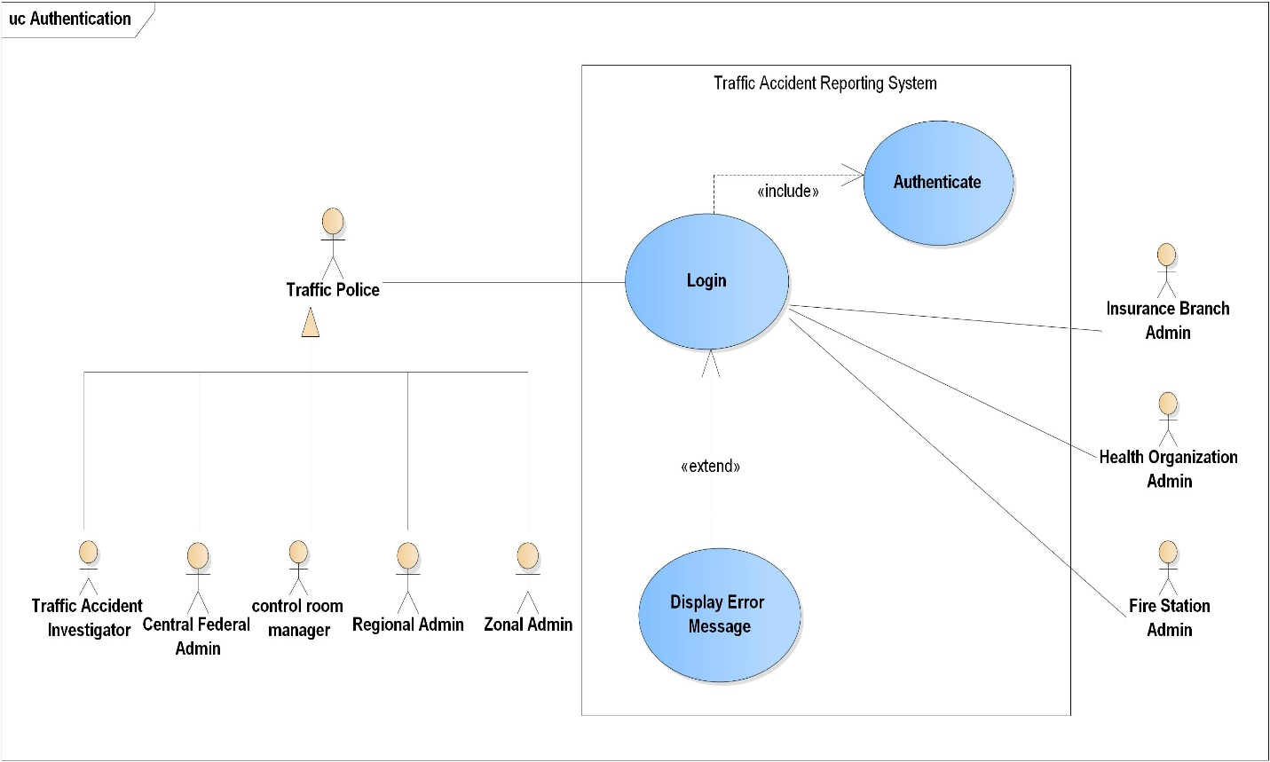

Figure 1: Use case diagram for Logging in and Authentication

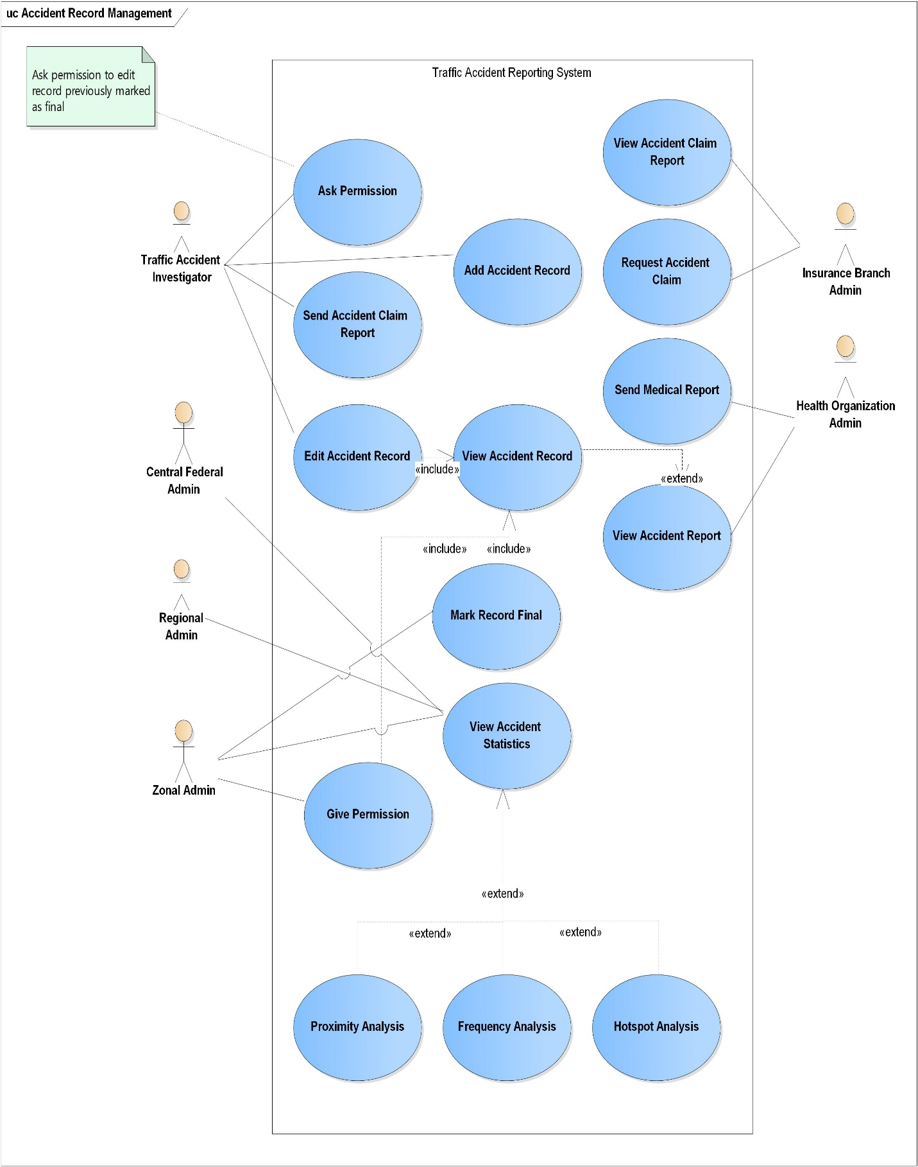

Figure 2: Use case diagram for Accident Records Management

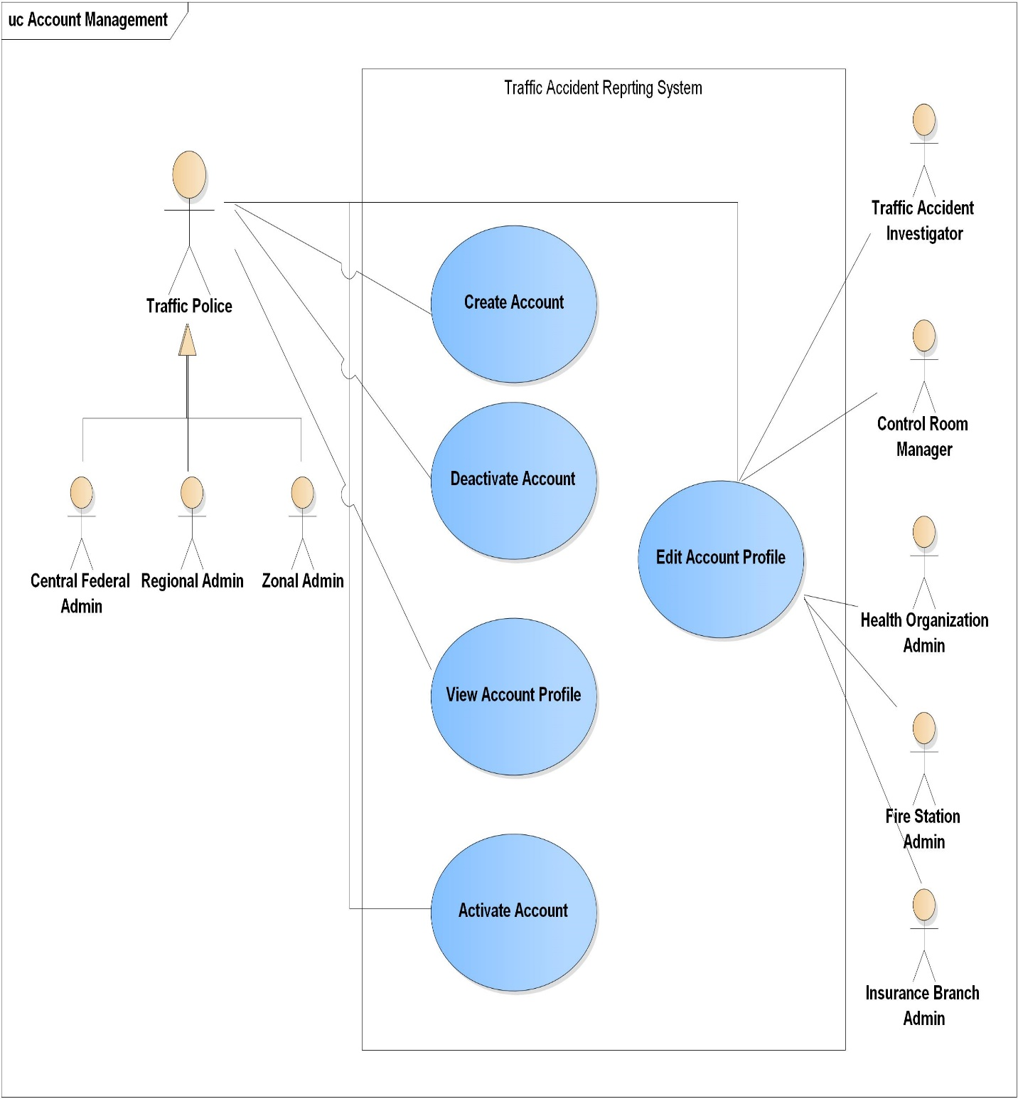

Figure 3: Use case diagram for Accounts Management

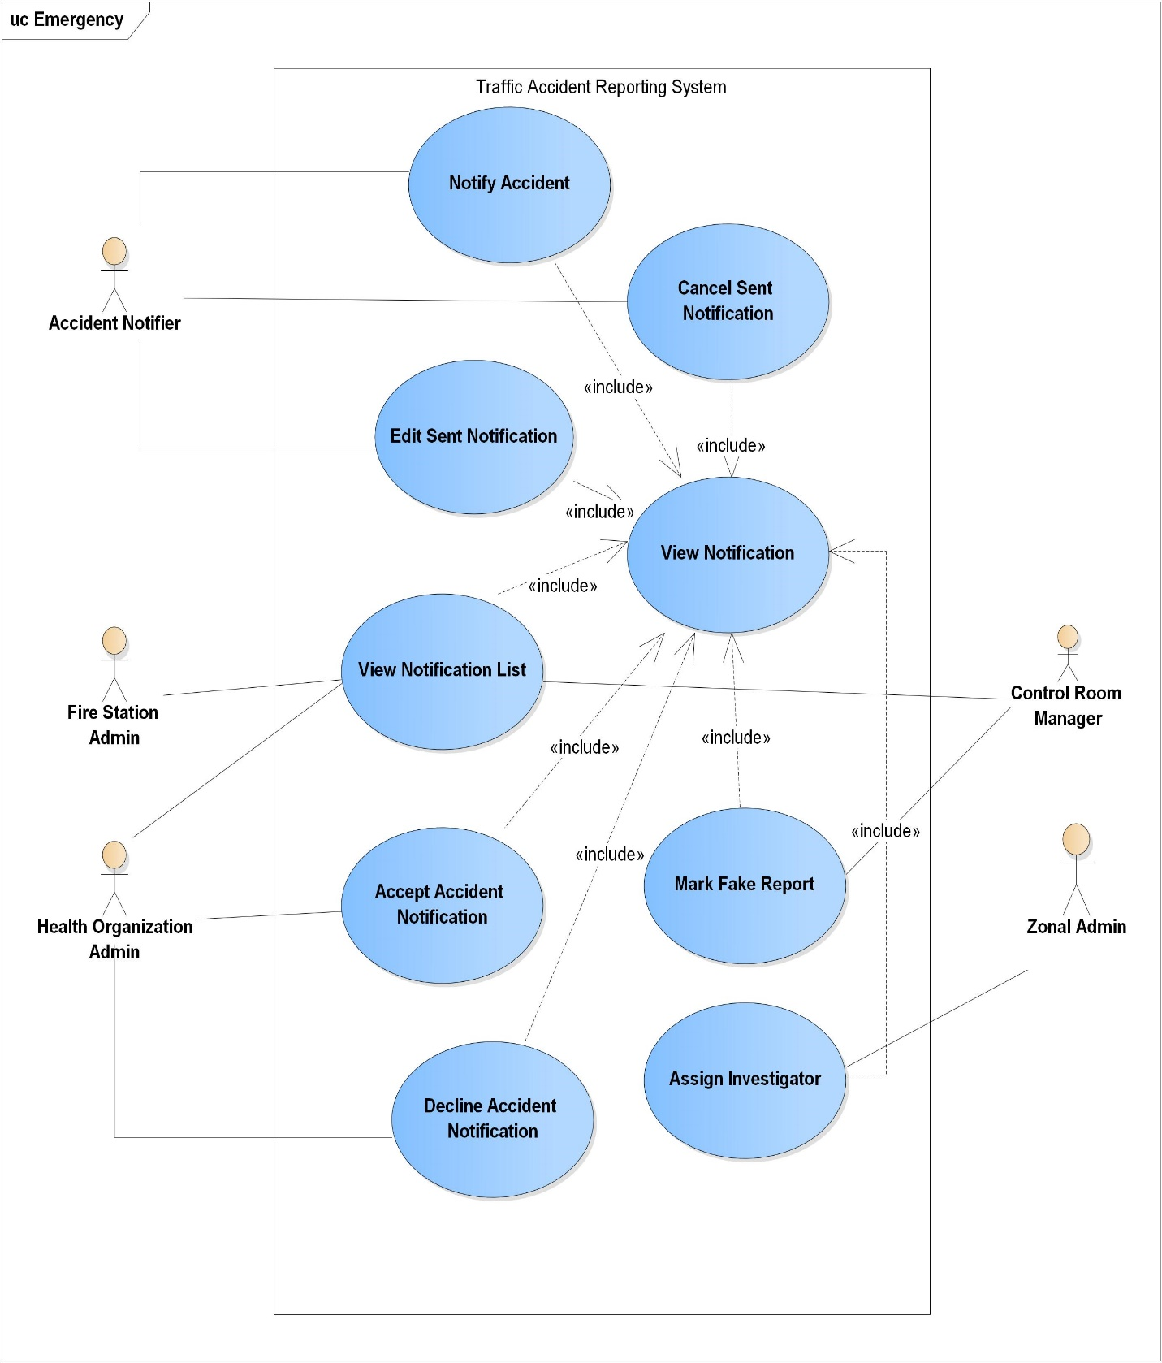

Figure 4: Use case diagram for Accident Notification

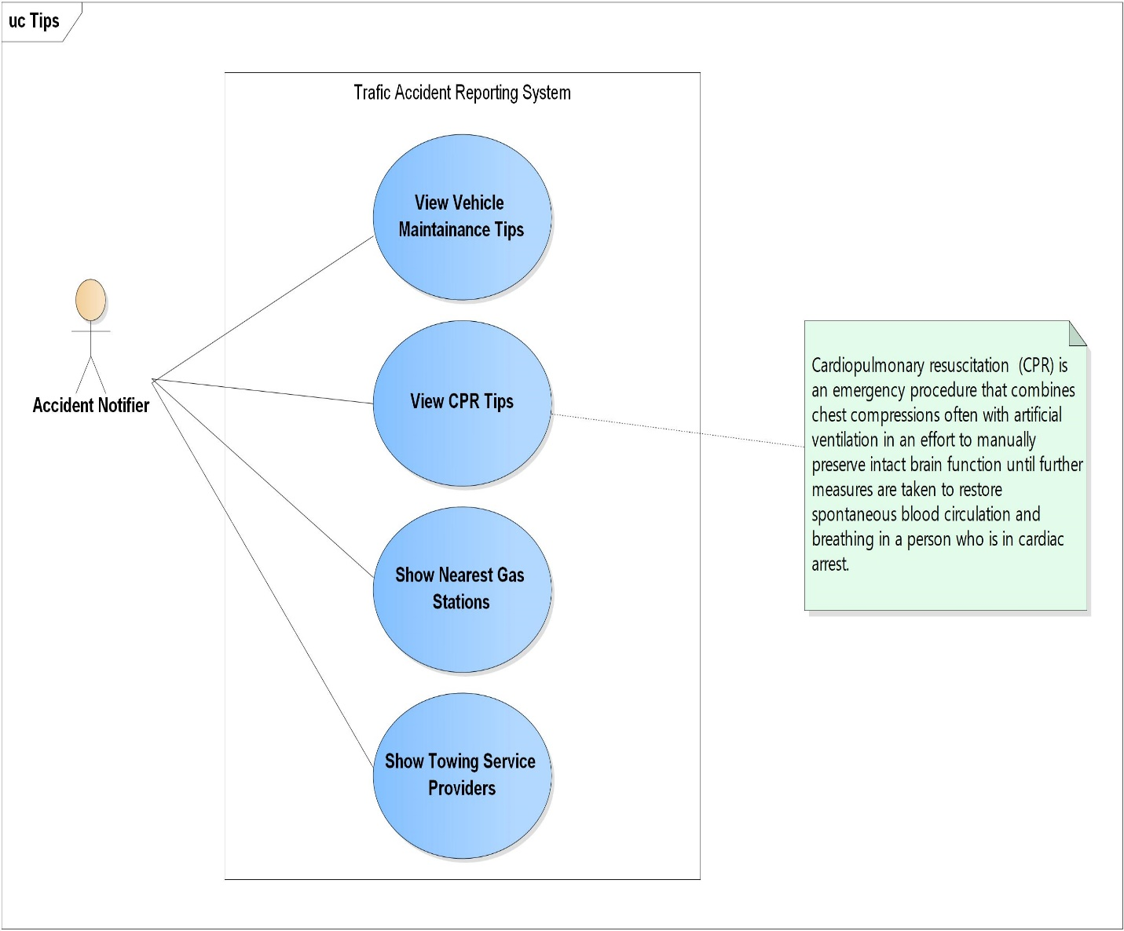

Figure 5: Use case diagram for providing tips

### Use case Description

table 2: User case description for creating an account

|  |  |  |
| --- | --- | --- |
| Use-case Name | Create Account | |
| Brief Description | Recording of new users based on their respective credential by providing required data input. | |
| Actor | Central Federal Administrator. Regional Administrator, Zonal Administrator. | |
| Used Use-case | - | |
| Precondition | 1. Central Federal Admin must exist in the system | |
| Post condition | 1. Password is going to generate and send by email 2. Actors will be granted access to the system after verification based on their access level. | |
| ACTOR | | SYSTEM |
| Flow of Activity | 1. Actor will open the website | 1. System render Home page |
| Scenario | 1. Create Regional Administrator 2. Actor request to create Regional Administrator 3. Actor fill profile information about The Regional Administrator. | 1. System render form to create Regional Administrator 2. System read input information 3. System verify input information and save to database if they are correct 4. System Send generated password to the Regional Administrator through specified email. |
| Actor | Central Federal Administrator | |
| Precondition | Central Federal Administrator must created | |
| Post-condition | A new Regional Administrator with authority to manage all activities under the specified region will be created | |
| Scenario | 1. Register Zonal Administrator 2. Actor request for creating zonal Administrator 3. The actor fills profile information about the zonal Administrator. | 1. System render create zonal administrator form 2. System read input information 3. The system verifies input information and registers to the database if they are correct. 4. The system sends a generated password through the specified email. |
| Actor | 1. Regional Administrator | |
| Precondition | Regional Administrator must be created | |
| Post-condition | A new zonal administrator with the authority to manage all activity throughout the specified zone will be created. | |
| Scenario | 1. Create Traffic Accident Investigator 2. Actor request for creating Traffic Accident Investigator 3. The actor fills profile information about the Traffic Police Investigator. | 1. System Render form for creating Traffic Accident Investigator 2. System read input information 3. The system verifies input information and saves it to the database if they are correct.   The system sends a generated password to the traffic police investigator through a specified email. |
| Actor | Zonal Administrator | |
| Precondition | Zonal Administrator must be created | |
| Post-condition | A new Traffic Police Accident Investigator will be created with the authority to manage traffic records within his/her level of access. | |
| Scenario | 1. Register Control Room Manager 2. Actor request for creating control room manager 3. Actor fill profile information about the Control Room Manager | 1. The system renders a form for creating Control Room Manager 2. System read input information 3. The system verifies input information and saves it in the database if they are correct. 4. The system sends the generated password to the Control Room Manager through the specified email. |
| Actor | Zonal Administrator | |
| Precondition | Zonal Administrator must be created | |
| Post-Condition | A new Control Room Manager will be created | |
| Scenario | 1. Register Health Organization Administrator 2. Actor request for creating Health Organization Administrator 3. Actor fill profile information about Hospital Administrator | 1. System form for creating new Health Organization Administrator 2. System read input information 3. The system verifies the account and saves to the database if they are correct 4. Send a generated password to the registered Hospital Administrator through a specified email. |
| Actor | Zonal Administrator | |
| Precondition | Zonal Administrator must be created | |
| Post-Condition | New Health Organization Administrator will be created | |
| Scenario | 1. Register Fire Station Administrator 2. Actor request for creating Fire station Administrator 3. Actor fill profile information about Fire Station Administrator. | 1. The system renders a form for creating Fire Station Administrator 2. System read input information 3. The system verifies input information and saves it to the database if they are correct.   Send generated password to the Fire Station Admin through specified email. |
| Actor | Zonal Administrator | |
| Precondition | Zonal Administrator must be created | |
| Post-condition | A new Fire station Administrator will be created | |
| Scenario | 1. Register Insurance Branch Manager 2. Actor request for creating new Insurance Branch Administrator   The actor fills profile information about the Insurance Branch Manager. | 1. The system renders a form for creating a new Insurance Branch Manager 2. System read input information 3. The system verifies information and saves it to the database if it is correct   Send a generated password to the branch admin through a specified email. |
| Actor | Zonal Administrator | |
| Precondition | Zonal Administrator must be created | |
| Post-Condition | A new Insurance Branch Administrator with the authority to request and view claim data will be created | |
| Exception | 1. If the actor input the wrong email   1a. if the specified email is not email  1b. if the email is already taken   1. If Actor input wrong address information   2a. if specified latitude is out of -90 to 90 range  2b. if specified longitude is out of -180 to 180 range   1. If Actor input incorrect phone number   3a. if a specified phone number has character  3b. if specified not valid in Ethiopia   1. If Actor input invalid input   4a. if Actor input very long or very short input   * Registration will be denied. * The actor will be notified about the situation. * The Actor will be asked to retry | |

Table 3: Use case description for authenticating

|  |  |  |
| --- | --- | --- |
| Use-case name | Authenticate | |
| Brief Description | Logging in authenticates the input given by the user before providing requested service | |
| Actor | Central Federal Administrator. Regional Administrator, Zonal Administrator, Traffic Accident Investigator, Control Room Manager, Insurance Branch Administrator, Health Organization Administrator, Fire Station Administrator. | |
| Precondition | The actor must be registered in the system. | |
| Post-condition | The actor will be able to get granted for access if his/her credential is verified. | |
| ACTOR | | SYSTEM |
| Flow of Activity | 1. Actor request for the login page. 2. Actor fill username and password. | 1. The system renders the login page. 2. The system verifies email and password then redirects to the actor’s homepage. |
| Scenario | 1. Actors have forgotten his password. 2. Actor press forget password button 3. Actor enter email address | 1. An override password will be sent to the actor via his/her email. |
| Exception | 1. Actor input incorrect username or password  * The actor notified about the situation. * The actor will be asked to re-enter the email and password. * The actor will be asked if he/she forgets his/her password. | |

Table 4: Use case description for Notify Accident

|  |  |  |
| --- | --- | --- |
| Use-case Name | Notify Accident | |
| Brief Description | The accident notifier fills notification detail and commands the system to send the notification. | |
| Actor | Accident Notifier | |
| Related Use-case | - | |
| precondition | The Actor must be registered by using a mobile application | |
| Post-condition | Accident Notification must reach the nearest Zonal Traffic Police, Health Organization, Fire Station based on the demand of the accident notifier. | |
| ACTOR | | SYSTEM |
| Flows of event | 1. Actor open traffic accident reporting mobile application. 2. The actor fills information about the accident. 3. Actor press notify button | 1. System open accident notifier form. 2. Accept Accident Notification and retrieve the location form GPS 3. The system notifies belonged institution based on the notifier demand |
| Exceptions | 1. Notify reported accident  * System Analyze the report * The system filters the accident * The system will not notify the belonged institution for the already reported accident.  1. Notify fake accident notification  * Control room manager make the report fake * The system will not notify belonged institutions for fake accident notification | |

Table 5: Use case description for View Notification

|  |  |  |
| --- | --- | --- |
| Use-case Name | View Notification | |
| Brief Description | Accident notifier and belonged instructions able to see accident notification details. | |
| Actor | Accident Notifier, Control Room Manager, Zonal Traffic Police, Health Organization Administrator, Fire Station Administrator. | |
| Related Use-case | Notify Accident | |
| Precondition | The accident should be notified before | |
| Post-Condition | - | |
| ACTOR | | SYSTEM |
| Flow of Activity | 1. The actor opens the traffic accident reporting system. 2. The actor views the accident notification details. | 1. System render all belonged accident notification to actors. |
| Scenario | 1. Accident Notifier view. 2. Go to the mobile app. 3. View Details of an accident by clicking one form his/her accident list. | 1. Send a list and details of the accident reported by the actor. |

Table 6: Use case description for Accident Notifier

|  |  |  |
| --- | --- | --- |
| Actor | Accident Notifier | |
| Precondition | Actors can only view accident notification, which is reported by themselves. | |
| Post-condition | All details of Actors Accident notifications will be pop up. | |
| Scenario | 1. Belonged Institution 2. See notification | 1. The System Send the accident notification to the belonged institution ( 2. Zone Traffic Police Administrator, 3. Health Organization Administrator 4. Fire Station Administrator   ) |

Table 7: Use case description for Edit Sent Notification

|  |  |  |
| --- | --- | --- |
| Use-case Name | Edit Sent Notification | |
| Brief description | Actor can edit sent accident report | |
| Actor | Accident Notifier | |
| Used Use-case | Notify accident | |
| Precondition | The actor can only edit accident reports, which are sent by themselves. | |
| Post-Condition | Edited Accident Notification must reach to the nearest Zonal Traffic Police, Health Organization, Fire Station based on the demand of the accident notifier. | |
| ACTOR | | SYSTEM |
| Flow of Activity | 1. The actor views accident details. 2. Actor Click Edit Button 3. Edit accident details. 4. Actor press update button | 1. The system renders Accident details to the actor. 2. System update accident details based on the notifier new input. |

Table 8: Use case description for Cancel Sent Notification

|  |  |  |
| --- | --- | --- |
| Use-case Name | Cancel Sent Notification | |
| Brief Description | The actor can cancel the notified accident in case of wrongdoing. | |
| Actor | Accident Notifier | |
| Used Use-case | Notify Accident, view accident | |
| Precondition | Actors can only cancel accident reports which are sent by themselves | |
| Post-Condition | Cancel Accident notification will reach to belonged institutions, those assigned to that accident | |
| ACTOR | | SYSTEM |
| Flow of Activity | 1. The actor views accident details. 2. Actor press Cancel Button. | 1. System Render Accident Details. 2. The system deletes accident notification reports and notifies belonged institutions. |

Table 9: Use case description for View Notification List

|  |  |  |
| --- | --- | --- |
| Use-case Name | View Notification List | |
| Brief Description | Accident Notifier and administrator of any belonged institution can see all accident notifications sent from accident notifier. | |
| Actor | Accident Notifier, Zone Traffic Police Administrator, Control Room Manager, Health Organization Administrator and Fire Station Administrator | |
| Used Use-case | Notify Accident, Accept Accident Notification | |
| precondition | An Actor can only see a list of accident reports that are sent by themselves or accepted by their organizations. | |
| Post-condition | - | |
| ACTOR | | SYSTEM |
| Flow of Activity | 1. Actor open system 2. Actor clicks on the reported accident list button. | 1. The system renders the list of accidents, which are belonged to the actor. |

Table 10: Use case description for Accept Accident Notification

|  |  |  |
| --- | --- | --- |
| Use-case Name | Accept Accident Notification | |
| Brief Description | Health Organization and Fire Station Accept accident notification if they can respond. | |
| Actor | Health organization, Fire Station | |
| Related Use-case | View Accident Notification | |
| Preconditions | Actors should view accident notification | |
| Post-Conditions | The system stops searching for the next nearest Health Organization and Fire Station. | |
| ACTOR | | SYSTEM |
| Flow of Activity | 1. The actor opens the website 2. Actor view Accident report notification. 3. Actor accept reported accident by clicking the accept button | 1. System Notify Accident to the actor 2. Stop searching the next nearest Health Organization and Fire Station. |

Table 11: Use case description for Decline Accident Notification

|  |  |  |
| --- | --- | --- |
| Use-case Name | Decline Accident Notification | |
| Brief Description | Health organizations and Fire stations can decline accident notification if they cannot responsible for the accident. | |
| Actor | Health organization and Fire Station. | |
| Used Use-case | View Accident Notification | |
| Precondition | Actors should view accident notification | |
| Post-condition | The system notifies the next nearest Health Organization and Fire Station. | |
| ACTOR | | SYSTEM |
| Flow of Activity | 1. System open the web-site 2. Actor view Accident report notification. 3. Actor decline reported accident by clicking the Decline button. | 1. System Notify Accident to the actor 2. System Notify the next nearest Health Organization and Fire Station based on the notifier demand. |

Table 12: Use case description for mark fake report

|  |  |  |
| --- | --- | --- |
| Use-case Name | Mark Fake Report | |
| Brief Description | Mark Traffic Accident reports which are sent from some irresponsible peoples. | |
| Actor | Control Room Manager | |
| Used Use-case | View Accident Notification | |
| Precondition | - | |
| Post-Condition | The Accident notification will be registered in the database as fake. | |
| Flow of Activity | ACTOR | SYSTEM |
|  | 1. The actor opens the website 2. See accident report notification 3. Click mark as a fake button | 1. The system renders accident notification list 2. The system updates the accident report as fake. |

|  |  |  |
| --- | --- | --- |
| Use-case Name | Assign Investigator | |
| Brief Description | Zone Traffic Administrator can assign the investigator after he/she accept a report from the control room. | |
| Actor | Zone Traffic Administrator | |
| Used Use-case | View Accident | |
| Precondition | - | |
| Post-condition | Investigator will assign to the accident. | |
| ACTOR | | SYSTEM |
| Flow of Activity | 1. Actor open website 2. View list of accident notification 3. Assign the Investigator to each accident. | 1. Render all accident notifications which are sent from Control room manager 2. The system saves the assigned Investigator. 3. The system notifies to the assigned Accident Investigator |

Table 13: Use case description for an add accident record

|  |  |  |
| --- | --- | --- |
| Use-case Name | Add Accident Record | |
| Brief Description | Traffic Police Investigator Add Accident to the central database by filling up some forms. | |
| Actor | Traffic Accident Investigator | |
| Used Use-case | Authenticate, Assigned Investigator | |
| Precondition | - | |
| Post-condition | The accident record will add to the central database | |
| ACTOR | | SYSTEM |
| Flow of Activity | 1. The actor opens the website 2. Request to Accident record form by clicking Add Accident Report 3. Fill Accident record form | 1. The system renders a form for adding new accident record 2. System read form data 3. The system verifies input information and saves it to the database if it is correct. |
| Exceptions | 1. If Actor input wrong address information   1a. if specified latitude is out of -90 to 90 range  1b. if specified longitude is out of -180 to 180 range | |

Table 14: Use case description for edit accident record

|  |  |  |
| --- | --- | --- |
| Use-case Name | Edit Accident Record | |
| Brief Description | The investigator who filled the record can update accident record details before marked as final. | |
| Actor | Traffic Police Investigator | |
| Used Use-case | Authenticate | |
| Precondition | Traffic Police Investigator can only edit non-final reports which are reported by him/her selves | |
| Post-Condition | The Traffic Accident Report will be updated according to the input from Traffic Investigator | |
| ACTOR | | SYSTEM |
| Flow of Activity | 1. Actor open website 2. Actor request for a list of his/her accident records 3. Actor request for Edit form by clicking Edit button 4. Actor fill edit form accordingly 5. Actor press update button | 1. The system renders a list of belonged accident records 2. System render edit record form 3. System Update the accident record according to Investigators input |

Table 15: Use case description for ask permission

|  |  |  |
| --- | --- | --- |
| Use-case Name | Ask Permission | |
| Brief Description | In order to edit finalized accident records, the investigator must get authorization from Zone Traffic Administrator | |
| Actor | Traffic Accident Investigator | |
| Used Use-case | Authenticate, Add Accident Record, Mark Record Final | |
| Precondition | The Traffic Accident record must be marked as final | |
| Post-condition | - | |
| ACTOR | | SYSTEM |
| Flow of Activity | 1. The actor opens the system 2. Request for a list of finalized Traffic record 3. Ask for permeation by clicking Ask Permeation button | 1. The system renders a list of finalized traffic records 2. The system sends permeation request to zonal Traffic Police Administrator |

Table 16: Use case description for send accident claim report

|  |  |  |
| --- | --- | --- |
| Use-case Name | Send Accident Claim Report | |
| Brief Description | Traffic Accident send Accident Claim Report based on Insurance Branch Request | |
| Actor | Traffic Accident Investigator | |
| Used Use-case | Authenticate, Request Accident Claim | |
| Precondition | Accident claim request must be sent from Insurance Branch Administrator | |
| Post-Condition | Insurance Branch Administrator will receive an Accident Claim report | |
| ACTOR | | SYSTEM |
| Flow of Activity | 1. Actor open system 2. Request for sent claim request page 3. Approve request by clicking Approve Button | 1. The system renders a list of claim requests 2. The system sent claim data to belonged insurance branch administrator |

Table 17: Use case description for viewing accident record

|  |  |  |
| --- | --- | --- |
| Use-case Name | View Accident Record | |
| Brief Description | Traffic police officials can view the details of an accident record according to their access level | |
| Actor | Central Federal Administrator, Regional Administrator, Zonal Administrator, Traffic Accident Investigator | |
| Used Use-case | Authenticate | |
| Precondition |  | |
| Post-Condition | Traffic police officials able to see traffic accident records with their access level | |
| ACTOR | | SYSTEM |
| Flow of Activity | 1. The actor opens the system 2. Actor request for a list of accident record by clicking show list of an accident record button 3. Actor request for details of accident by clicking view Accident Details button | 1. The system renders a list of recorded accident 2. The system renders details of a specific accident |

Table 18: Use case description for view accident claim report

|  |  |  |
| --- | --- | --- |
| Use-case Name | View Accident Claim Report | |
| Brief Description | Branch Insurance company view Accident Claim Report which is sent from Traffic Police Investigator based on their request | |
| Actor | Insurance Branch Administrator | |
| Used Use-case | Authenticate, | |
| Precondition | Insurance Branch Manager able to see the claim of their customers with a grant from a traffic police investigator | |
| Post-Condition | - | |
| ACTOR | | SYSTEM |
| Flow of activity | 1. The actor opens the website 2. Request for a list of Accident claim by clicking accident claim list button 3. Request for details of accident claim by clicking the View Detail button. | 1. The system renders a list of accident claim which are belonged to the Insurance Company 2. The system renders details of a specific accident claim. |

Table 19: Use case description for request accident claim

|  |  |  |
| --- | --- | --- |
| Use-case Name | Request Accident Claim | |
| Brief description | Insurance Branch Manager request accident claim report of their customers from a traffic police investigator | |
| Actor | Insurance Branch Manager | |
| Used Use-Case | Authenticate | |
| Precondition | - | |
| Post-Condition |  | |
| ACTOR | | SYSTEM |
| Flow of Activity | 1. The actor opens the website 2. Request Accident claim by clicking the accident Send Claim Request button | 1. The system sent claim request to the belonged traffic police investigator |

Table 20: Use case description for send medical report

|  |  |  |
| --- | --- | --- |
| Use-case Name | Send Medical Report | |
| Brief Description | Health organization sent a medical report of Traffic Accident victim, On-demand of traffic investigator | |
| Actor | Health Organization Administrator | |
| Used Use-case | Authenticate | |
| Precondition | - | |
| Post-Condition | Accident victim record will be sent to Traffic Accident Investigator | |
| ACTOR | | SYSTEM |
| Flow of Activity | 1. The actor opens the system 2. Send victims records by clicking Send Medical Report Button. | 1. Sent Victim Medical Report to the investigator. |

Table 21: Use case description for mark record final

|  |  |  |
| --- | --- | --- |
| Use-case Name | Mark Record Final | |
| Brief Description | Traffic Accident records will be marked as final due to time or when Traffic Police Investigator mark the report as final | |
| Actor | Traffic Accident Investigator | |
| Used Use-case | Authenticate | |
| Precondition |  | |
| Post-Condition | Finalized Accident record will not be edited without zone administrator permission | |
| ACTOR | | SYSTEM |
| Flow of Activity | 1. Actor open system 2. Request for a list of traffic accident records 3. Finalize traffic accident records by clicking Make Final Button. | 1. The system renders a list of accident records 2. The system finalizes the traffic accident record, which is specified by the actor. |

Table 22: Use case description for give permission

|  |  |  |
| --- | --- | --- |
| Use-case Name | Give Permission | |
| Brief Description | Zone Administrator give permission to Traffic Accident Investigator in order to edit finalized accident record. | |
| Actor | Zone Administrator | |
| Used Use-Case | Authenticate | |
| Precondition | Traffic Accident investigator must send permeation request | |
| Post-Condition | A belonged Traffic Accident Investigator will grant to edit the specified traffic accident record | |
| ACTOR | | SYSTEM |
| Flow of Activity | 1. Actor open system 2. Request for a list of traffic investigator permeation request 3. Give Permeation by clicking Give permeation request. | 1. The system renders a list of Permeation request 2. The system activates a traffic accident report which is specified by the actor. 3. System Notify the belonged Traffic Accident Investigator |

Table 23: Use case description for view accident statistics

|  |  |  |
| --- | --- | --- |
| Use-case Name | View Accident Statistics | |
| Brief Description | Traffic Police officials see statistics of an accident based on their access level | |
| Actor | Central Federal Admin, Regional Traffic Police Administrator, Zonal Traffic Police Investigator | |
| Used Use-case | Authenticate | |
| Precondition | Actors can only view accident statistics of their access level | |
| Post-Condition | Traffic Police officials able to see traffic accident statistics in a different format | |
| ACTOR | | SYSTEM |
| Flow of Activity | 1. The actor opens the System 2. The actor requests for Accident Statistics by clicking Show Statistics button 3. The actor changes statistics format by clicking on different options. | 1. The system renders accident statistics by using the default format 2. System change statistics format based on the actor’s preference. |

Table 24: Use case description for deactivate account

|  |  |  |
| --- | --- | --- |
| Use-case Name | Deactivate Account | |
| Brief Description | Higher Traffic officials can deactivate account which is created by their access level | |
| Actor | Central Federal Administrator, Regional Administrator, Zonal Administrator | |
| Used Use-case | authenticate | |
| Precondition | Traffic Officials can deactivate accounts created with their access level | |
| Post-Condition | The deactivated account will not be functional | |
| ACTOR | | SYSTEM |
| Flow of Activity | 1. Actor open website 2. Actor request for a list of low-level officials clicking the list of officials 3. The actor deactivates accounts by clicking Deactivate Button. | 1. The system renders a list of low-level officials that are created at the actor’s access level. 2. System update account as deactivate |

Table 25: Use case description for view account profile

|  |  |  |
| --- | --- | --- |
| Use-case Name | View Account Profile | |
| Brief Description | Actors can see details about their and others account those are created under their access level | |
| Actor | Central Federal Administrator, Regional Administrator, Zonal Administrator, Traffic Accident Investigator, Control Room Manager, Health Organization Administrator, Health Organization Admin, Fire Station Administrator, Insurance Branch Administrator | |
| Used Use-case | Authenticate | |
| Precondition | Officials can only view their or others profile those are created under their access level but not else | |
| Post-Condition | - | |
| ACTOR | | SYSTEM |
| Flow of Activity | 1. Actor open website 2. Actor view profile by pressing the view profile option | 1. The system renders actors profile information |
| Scenario | 1. View Account Profile 2. Actor open website 3. Actor Request for details of account profile by clicking Profile Button | 1. System Render actors Account profile |
| Scenario | 1. View Others Account profile 2. Actor open website 3. Actor Request for a list of Accounts which are created at their access level 4. Actor request for profile details of a specific actor by clicking the profile button. | 1. The system renders a list of an account which are created with an access level of the actor 2. The system renders detail profile information of the actor from the list |

Table 26: Use case description for edit account profile

|  |  |  |
| --- | --- | --- |
| Use-case Name | Edit Account Profile | |
| Brief Description | Actors can update their account profile details | |
| Actor | Central Federal Administrator, Regional Administrator, Zonal Administrator, Traffic Accident Investigator, Control Room Manager, Health Organization Administrator, Health Organization Admin, Fire Station Administrator, Insurance Branch Administrator | |
| Precondition | - | |
| Post-Condition | Actor Account Details will be updated according to his/her input | |
| ACTOR | | SYSTEM |
| Flow of Activity | 1. Actor open website 2. Actor request for a profile by clicking the profile button 3. Actor request for changing profile clicking the change profile button 4. After filling forms actors command the system to change profile according to users input | 1. System render profile detail 2. System render edit profile forms 3. System update account details according to users input |

Table 27: Use case description for activate account

|  |  |  |
| --- | --- | --- |
| Use-case Name | Activate Account | |
| Brief Description | Traffic higher officials can activate account those have been deactivated at their access level | |
| Actors | Federal Central Administrator, Regional Administrator, Zone Administrator | |
| Used Use-case | Authenticate | |
| Precondition |  | |
| Post-Condition | Accounts will be functional | |
| ACTOR | | SYSTEM |
| Flow of control | 1. Actor open website 2. Actor Request for a list of the deactivated account which exists under his/her access level 3. Actor Activate accounts by clicking the activate button | 1. The system renders Deactivate Accounts which are under Actors Access level 2. System Activate Accounts those specified by the actor |

Table 28: Use case description for view vehicle maintenance tips

|  |  |  |
| --- | --- | --- |
| Use-case Name | View Vehicle Maintenance Tips | |
| Brief Description | People who use the mobile application can get different 2D animated Vehicle Maintenance tips accordingly | |
| Actor | Accident Notifier | |
| Used Use-case | - | |
| Precondition | - | |
| Post-Condition | - | |
| SYSTEM | | ACTOR |
| Flow of Activity | 1. Actor Open The mobile application 2. Actor click Maintenance help button 3. Actor select one form listed vehicle maintenance tips 4. Actor view tip detail by swiping right and left | 1. System Render a list of vehicle maintenance tips 2. System Render Details of Specified Tips |

Table 29: Use case description for view CPR tips

|  |  |  |
| --- | --- | --- |
| Use-case Name | View CPR Tips | |
| Brief Description | people who use the mobile application can get different 2D animated CPR tips | |
| Actor | Accident Notifier | |
| Used Use-case | - | |
| Precondition | - | |
| Post-condition | - | |
| ACTOR | | SYSTEM |
| Flow of Activity | 1. Actor Open The mobile application 2. Actor click CRT help button 3. Actor select one form listed CRT tips   Actor view tip detail by swiping right and left | 1. System render list of CRT helps 2. System details of Specified CRT tip |

Table 30: Use case description for show nearest gas station

|  |  |  |
| --- | --- | --- |
| Use-case Name | Show Nearest Gas Station | |
| Brief Description | Nearest Gas Station Provider enables the user of the system to locate service according to their location which gathered from GPS. | |
| Actor | Accident Notifier | |
| Used Use-case | - | |
| Precondition | - | |
| Post-Condition | - | |
| SYSTEM | | ACTOR |
| Flow of Activity | 1. The actor opens the system 2. Actor click for tips button 3. Actor click nearest gas Station in order to locate the nearest gas station | 1. The system renders the nearest Gas Station |

Table 31: Use case description for show nearest towing service provider

|  |  |  |  |
| --- | --- | --- | --- |
| Use-case Name | | Show Nearest Towing Service Provider | |
| Brief Description | | Nearest Towing Service Provider Locator enables the user of the system to locate service according to their location which gathered from GPS. | |
| Actor | | Accident Notifier | |
| Used Use-case | | - | |
| Precondition | | - | |
| Post-Condition | | - | |
| ACTOR | | | SYSTEM |
| Flow activity | 1. The actor opens the system 2. Actor click for tips button 3. Actor click Nearest Towing in order to locate the nearest towing center | | 1. The system renders the nearest Towing center provider |

### Activity Diagram

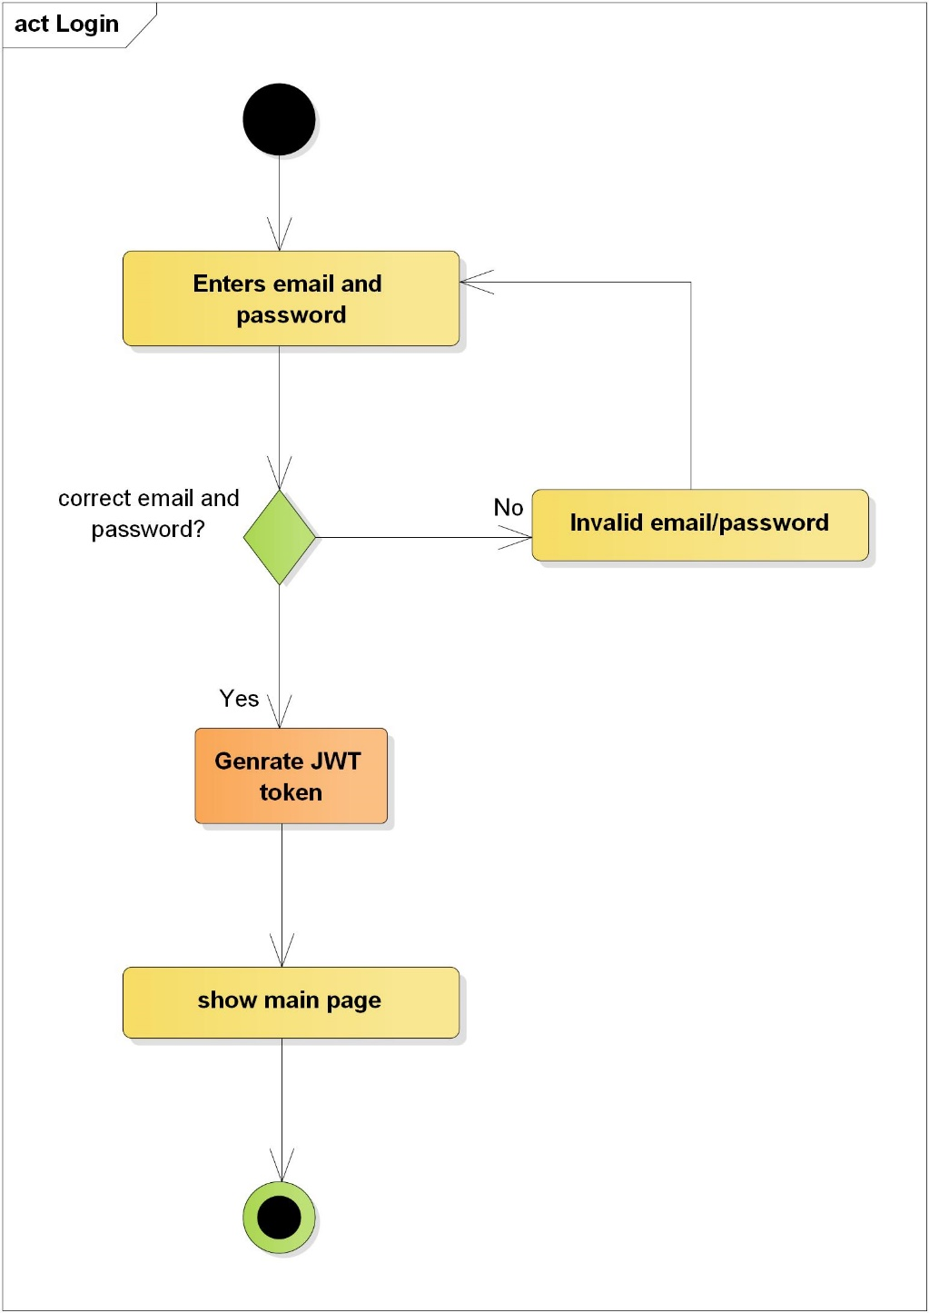

Figure 6: Activity diagram for login authentication

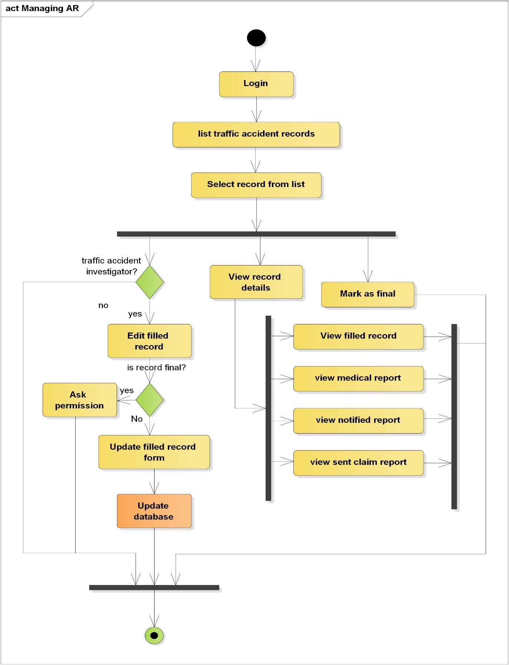

Figure 7: activity diagram for viewing accident record, editing and marking as final

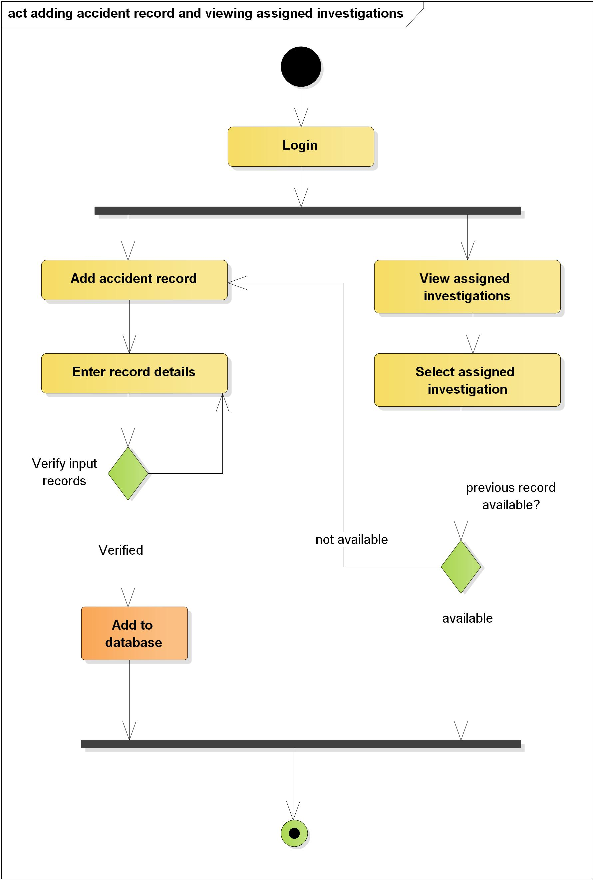

Figure 8: Activity diagram for adding accident record and viewing assigned investigations

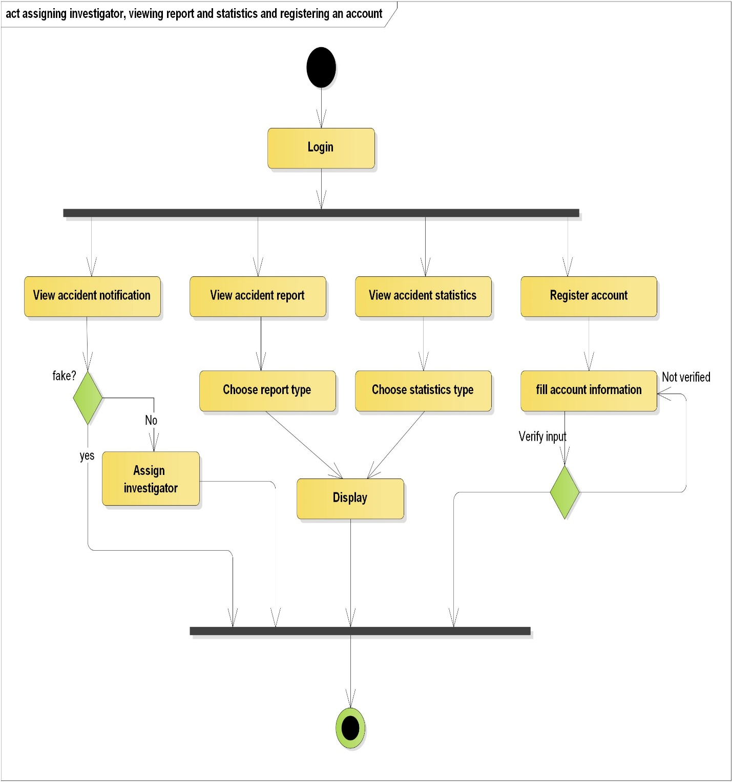

Figure 9: Activity diagram for assigning investigator, viewing report and statistics and registering an account

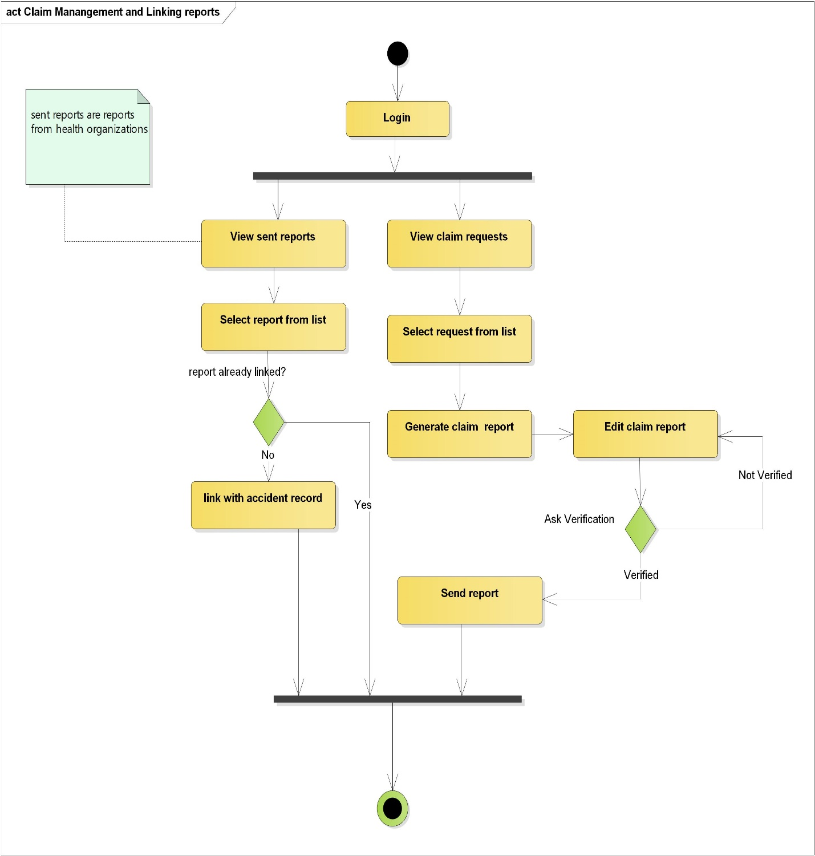

Figure 10: Activity diagram for managing claim reports and linking reports

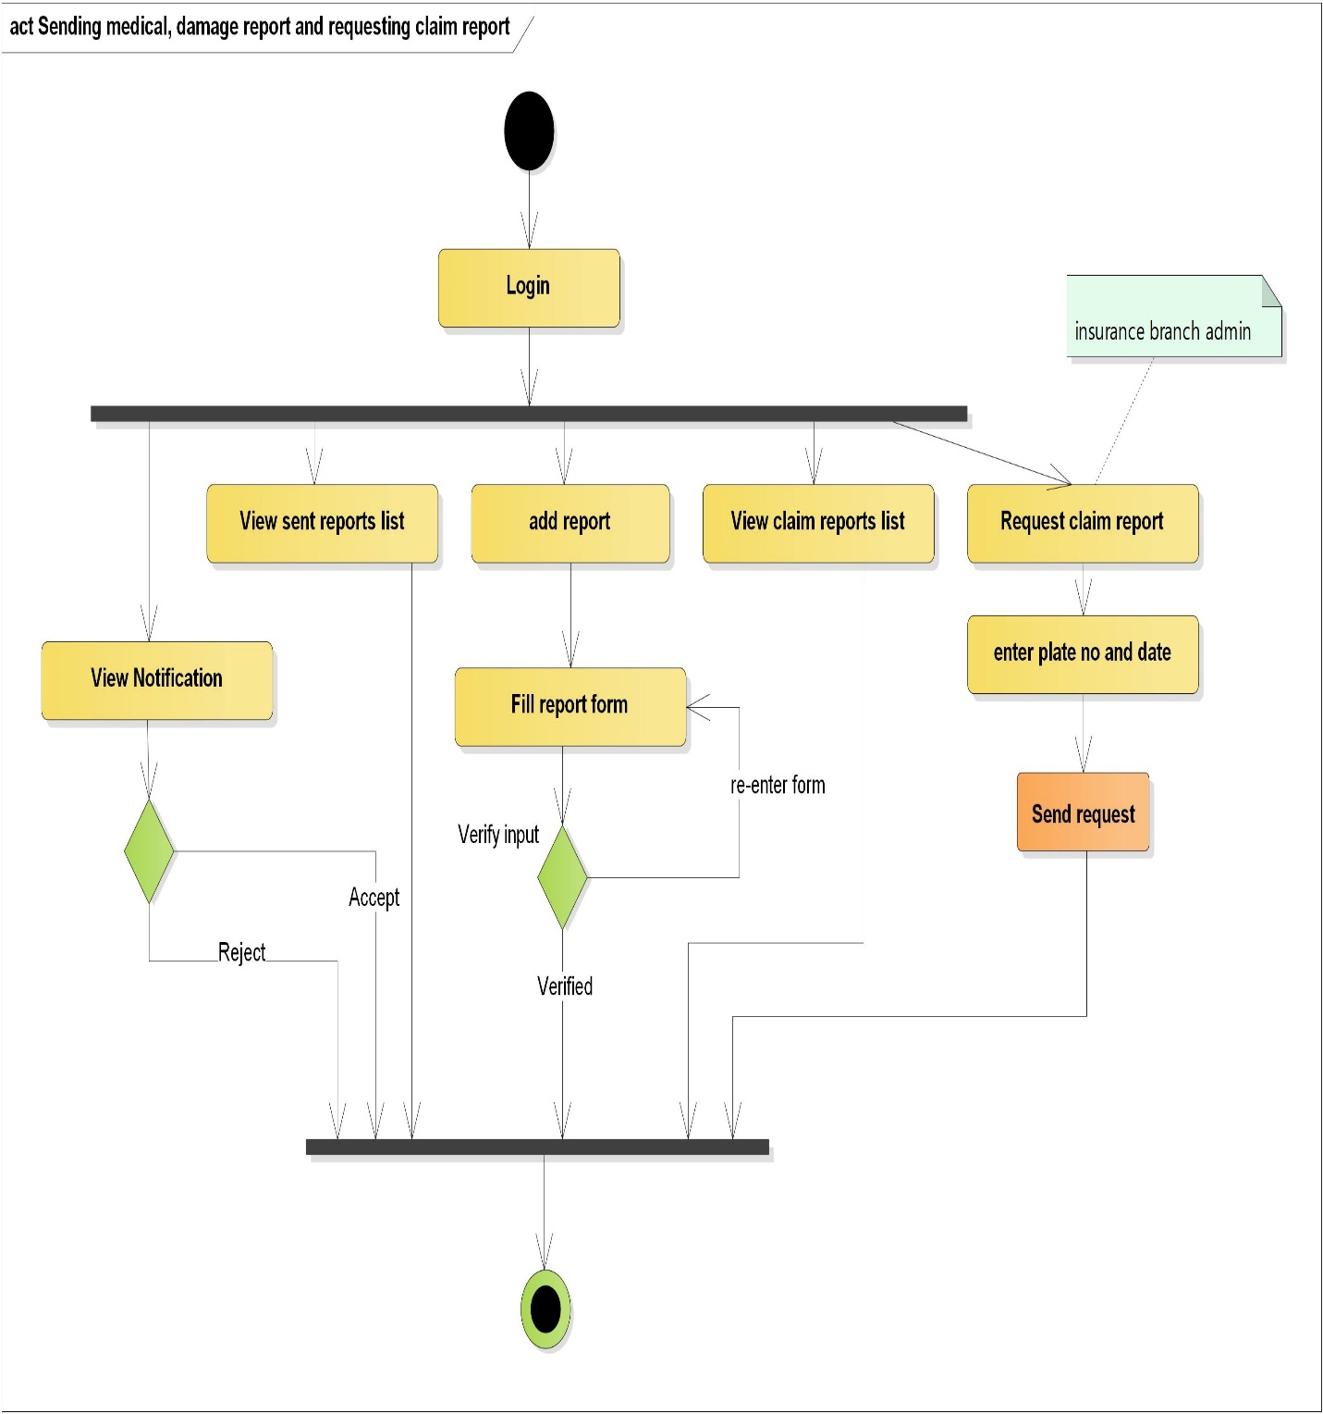

Figure 11: Activity diagram for sending a medical report, accepting and rejecting notification and requesting claim report

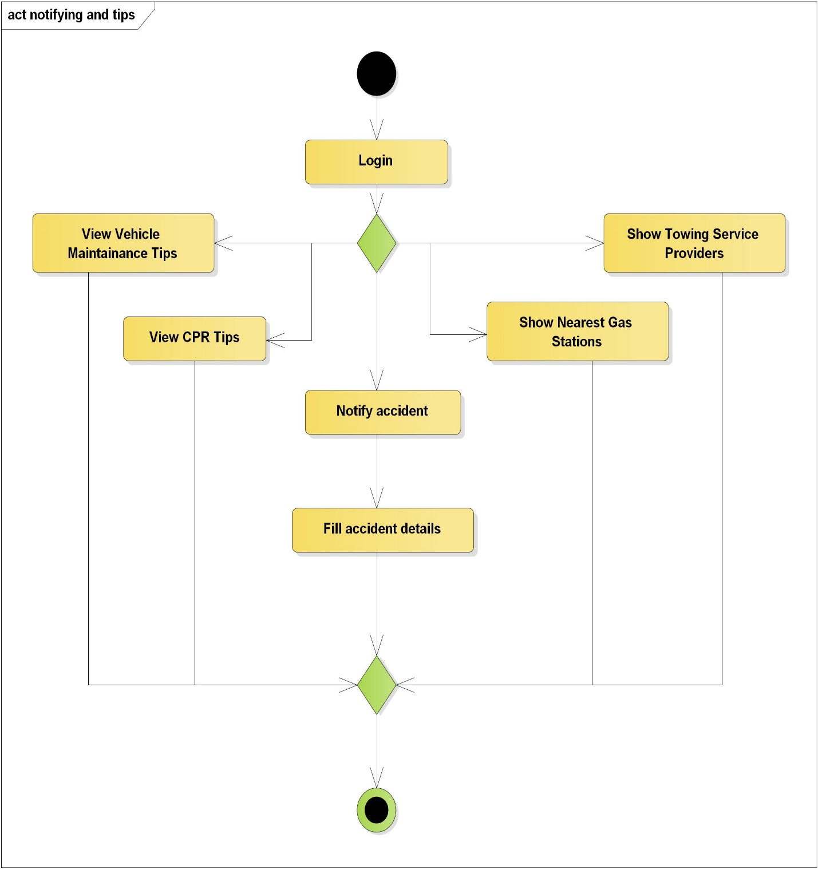

Figure 12: Activity diagram for notifying an accident and viewing tips and helps

## Dynamic Modeling

### Sequence Diagram

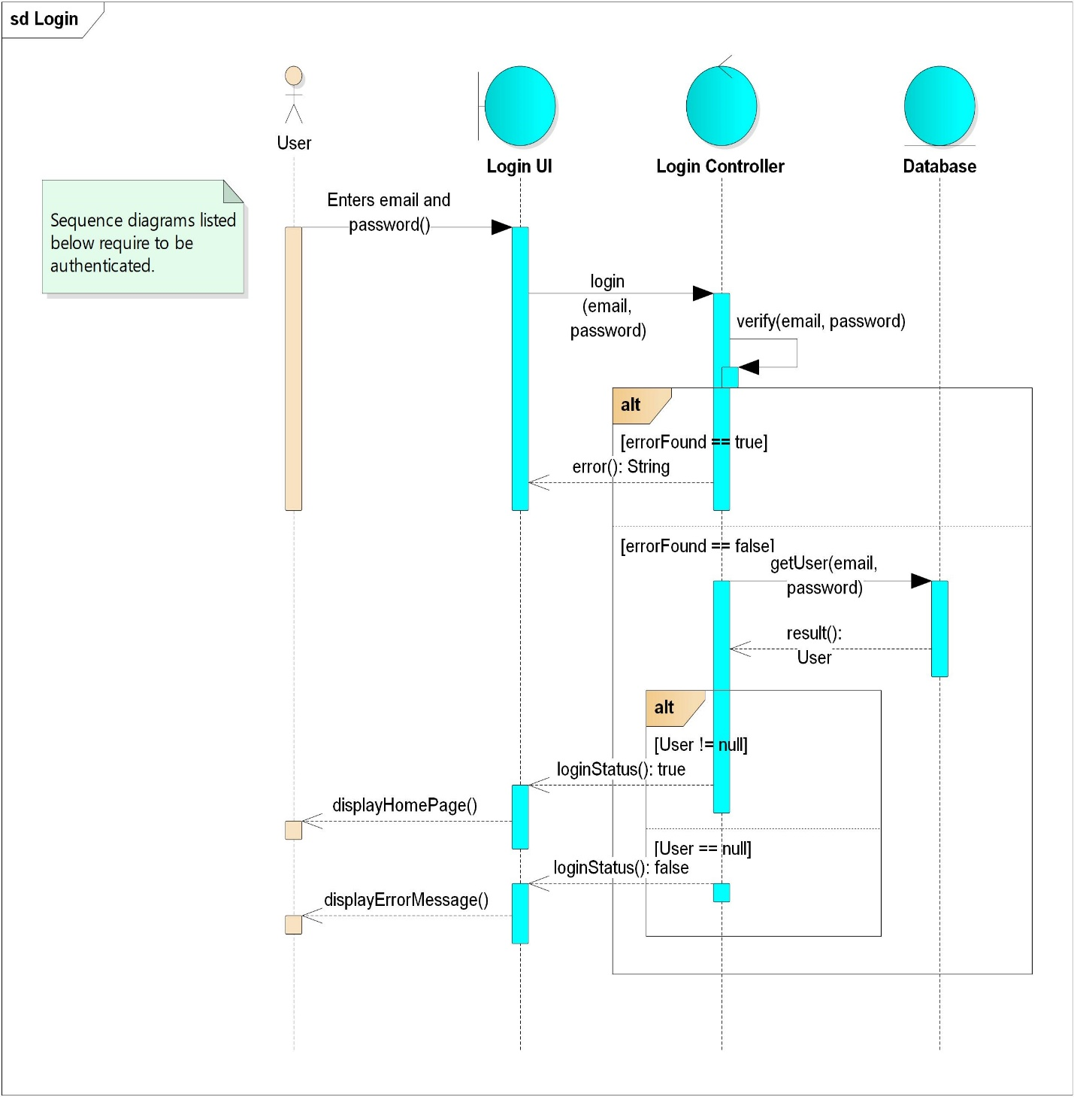

Figure 13: Sequence diagram for login

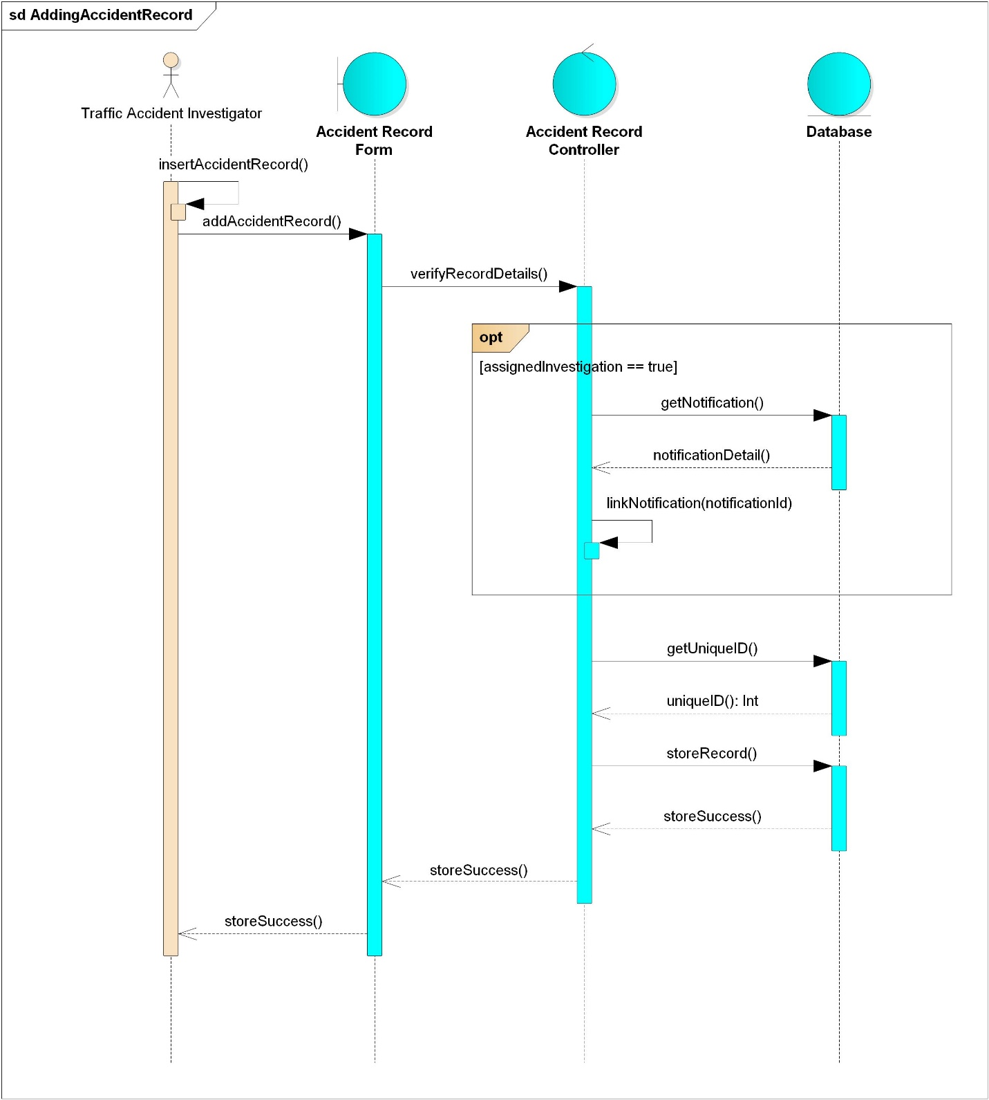

Figure 14: Sequence diagram for adding accident record

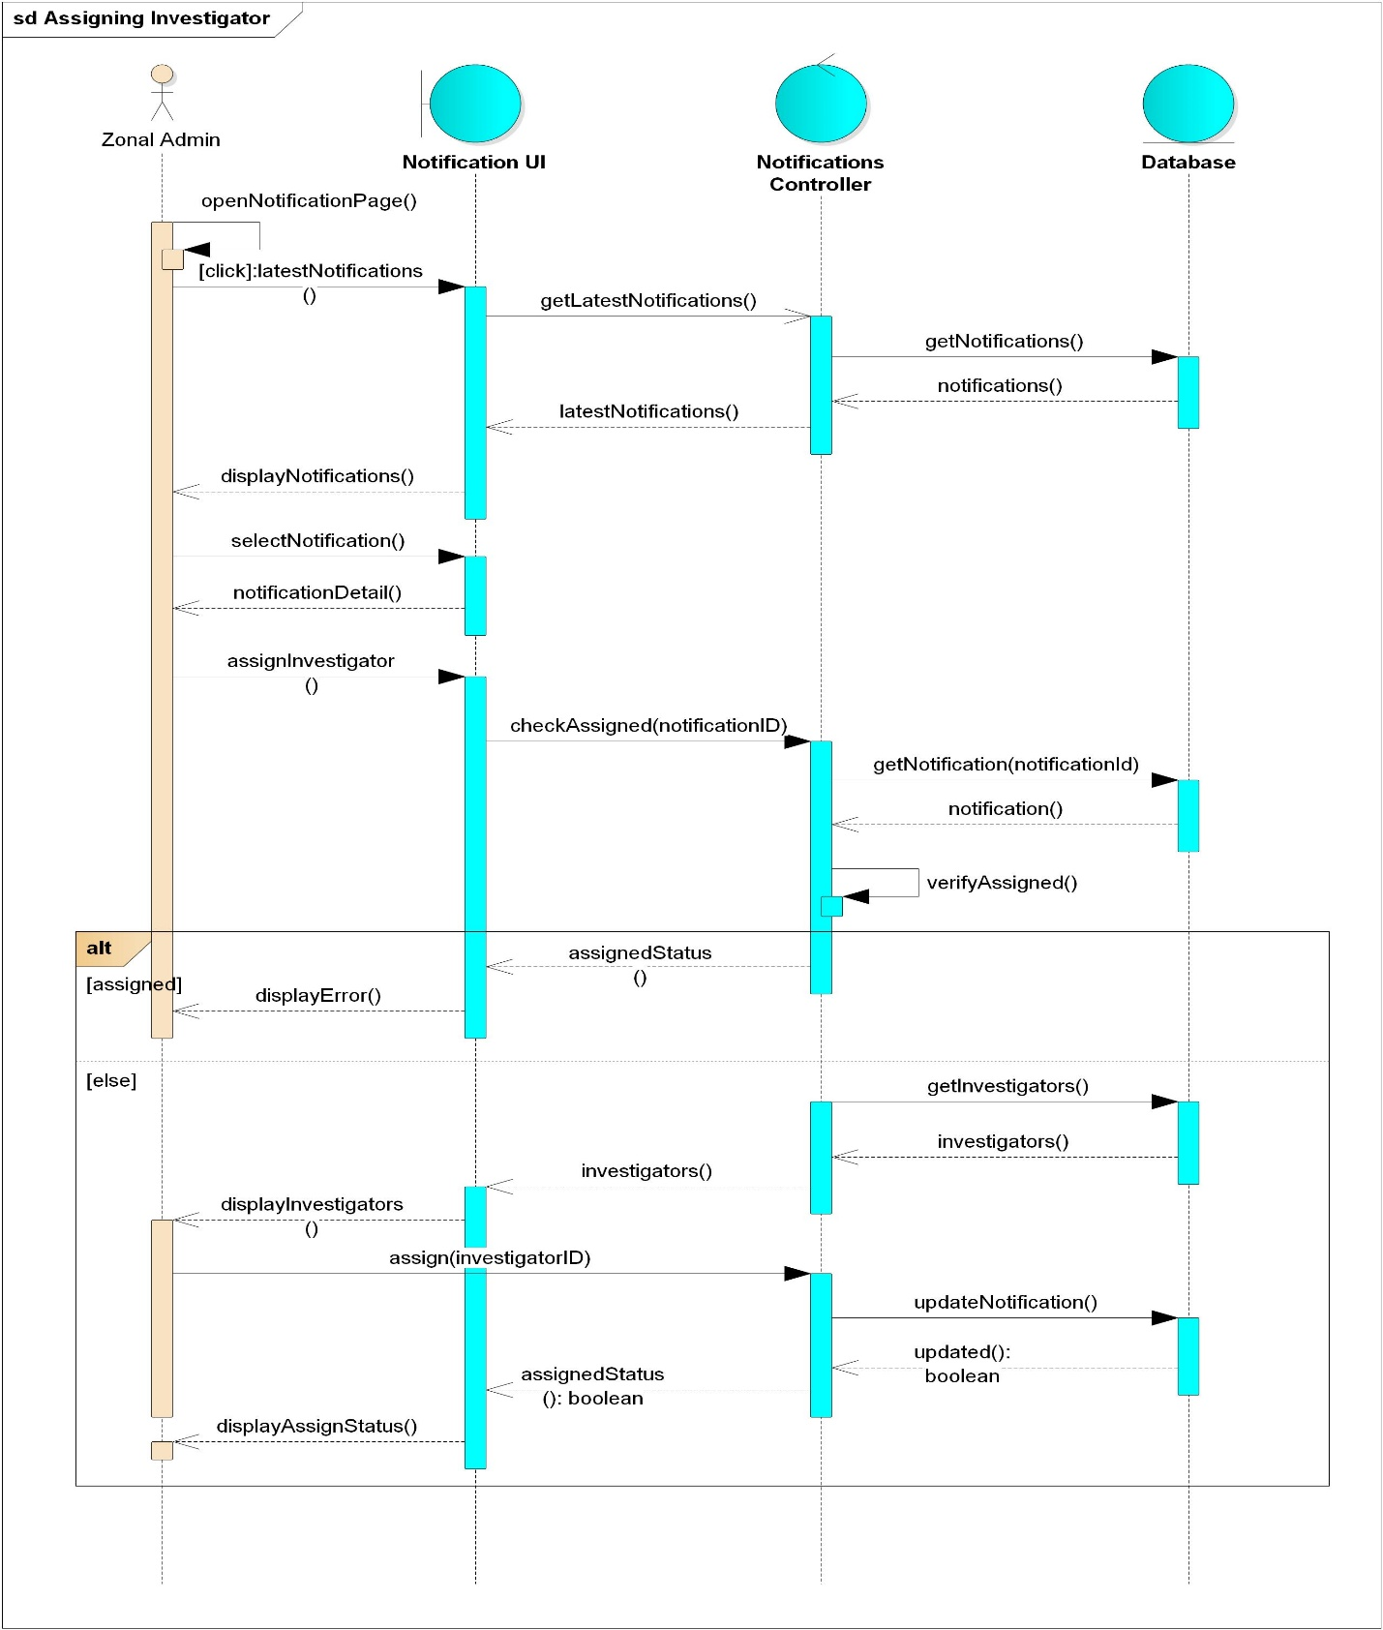

Figure 15: Sequence diagram for assigning an investigator

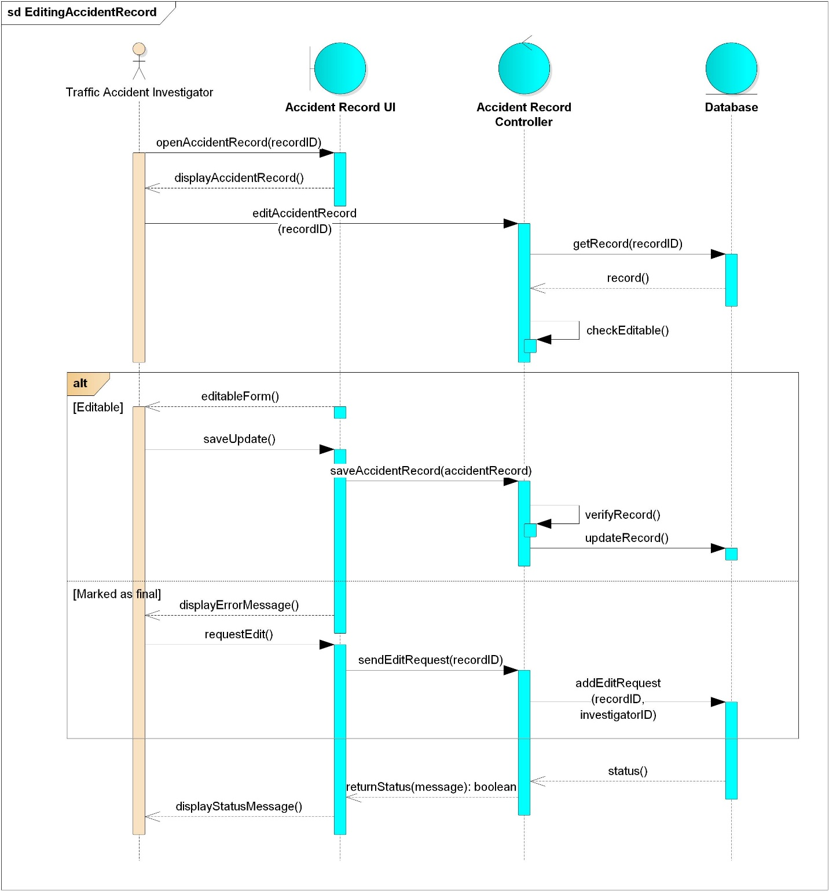

Figure 16: Sequence diagram for editing accident record

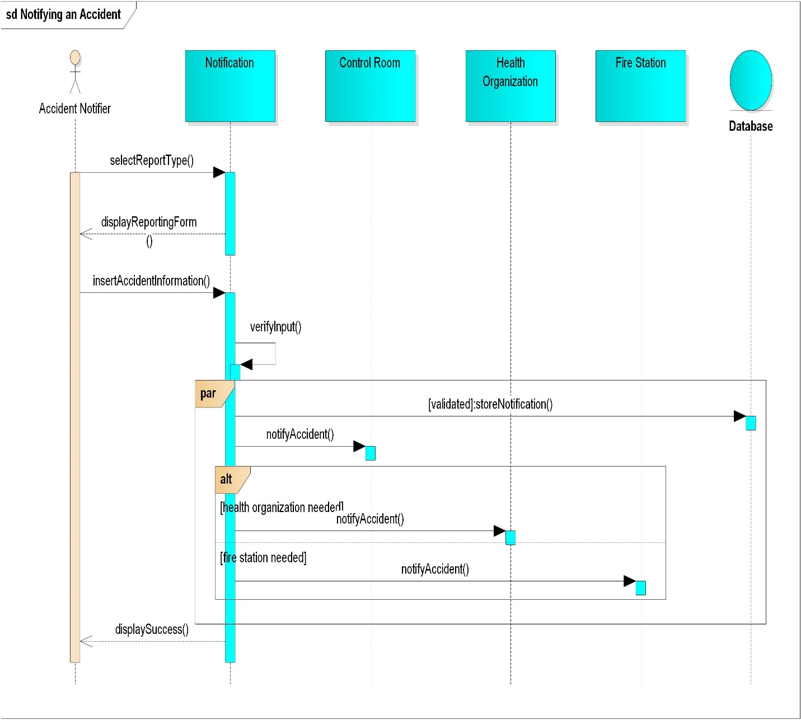

Figure 17: Sequence diagram for notifying an accident

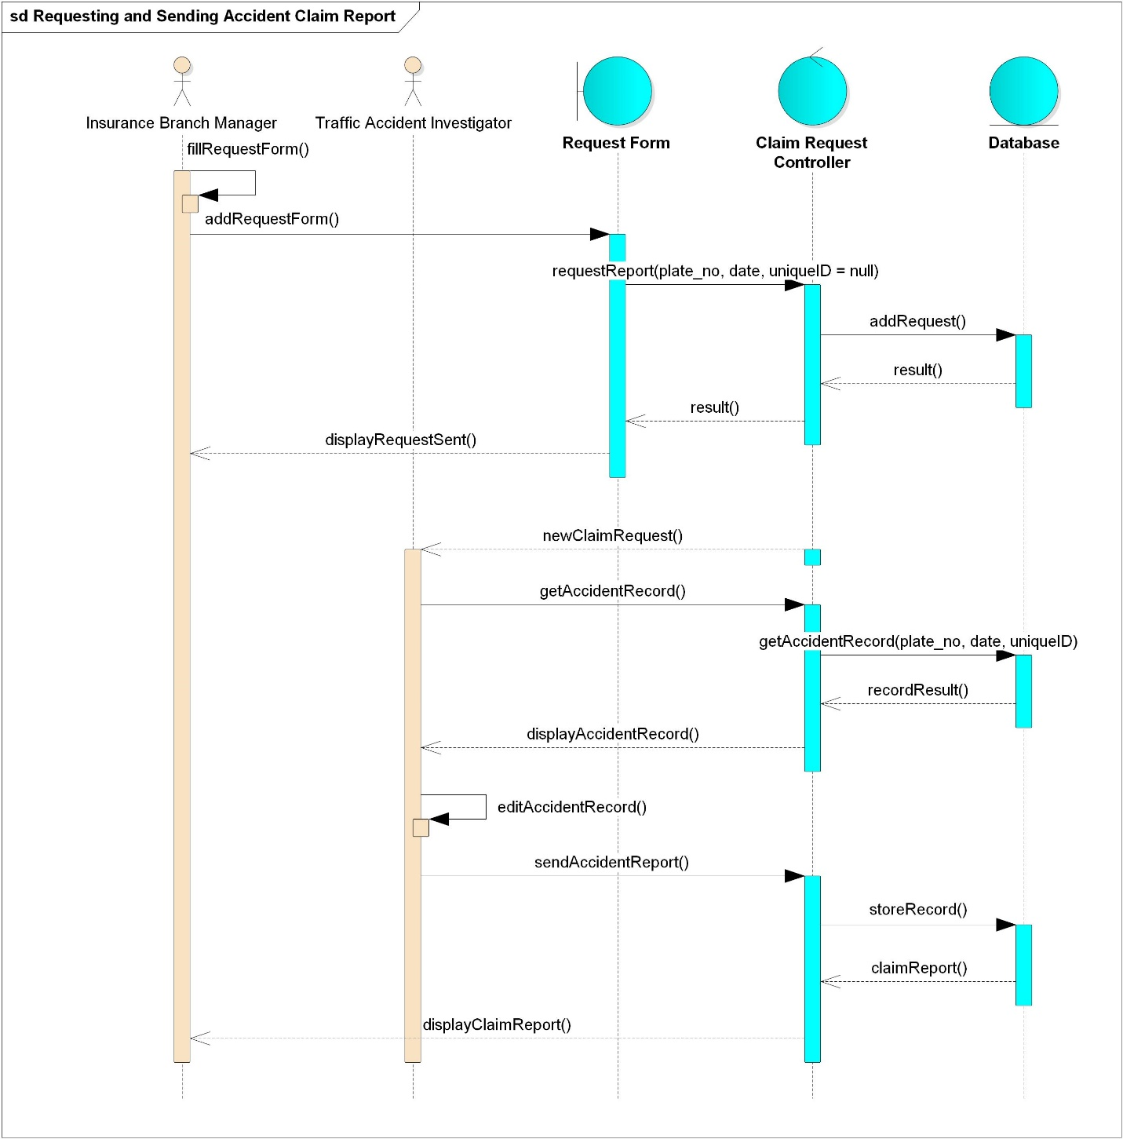

Figure 18: Sequence diagram for requesting and sending accident claim report

### State Diagram

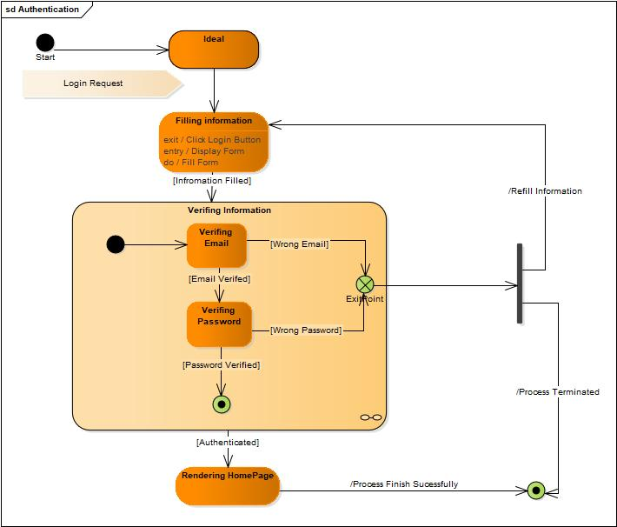

Figure 19: State diagram for authentication

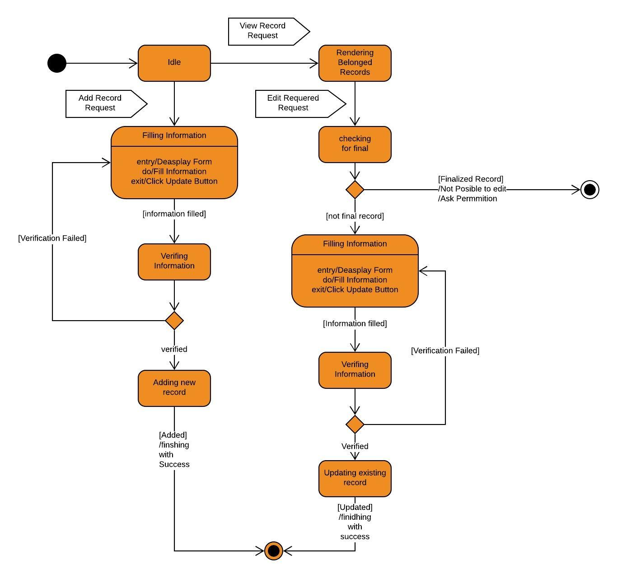

Figure 20: State diagram for adding and editing traffic accident record

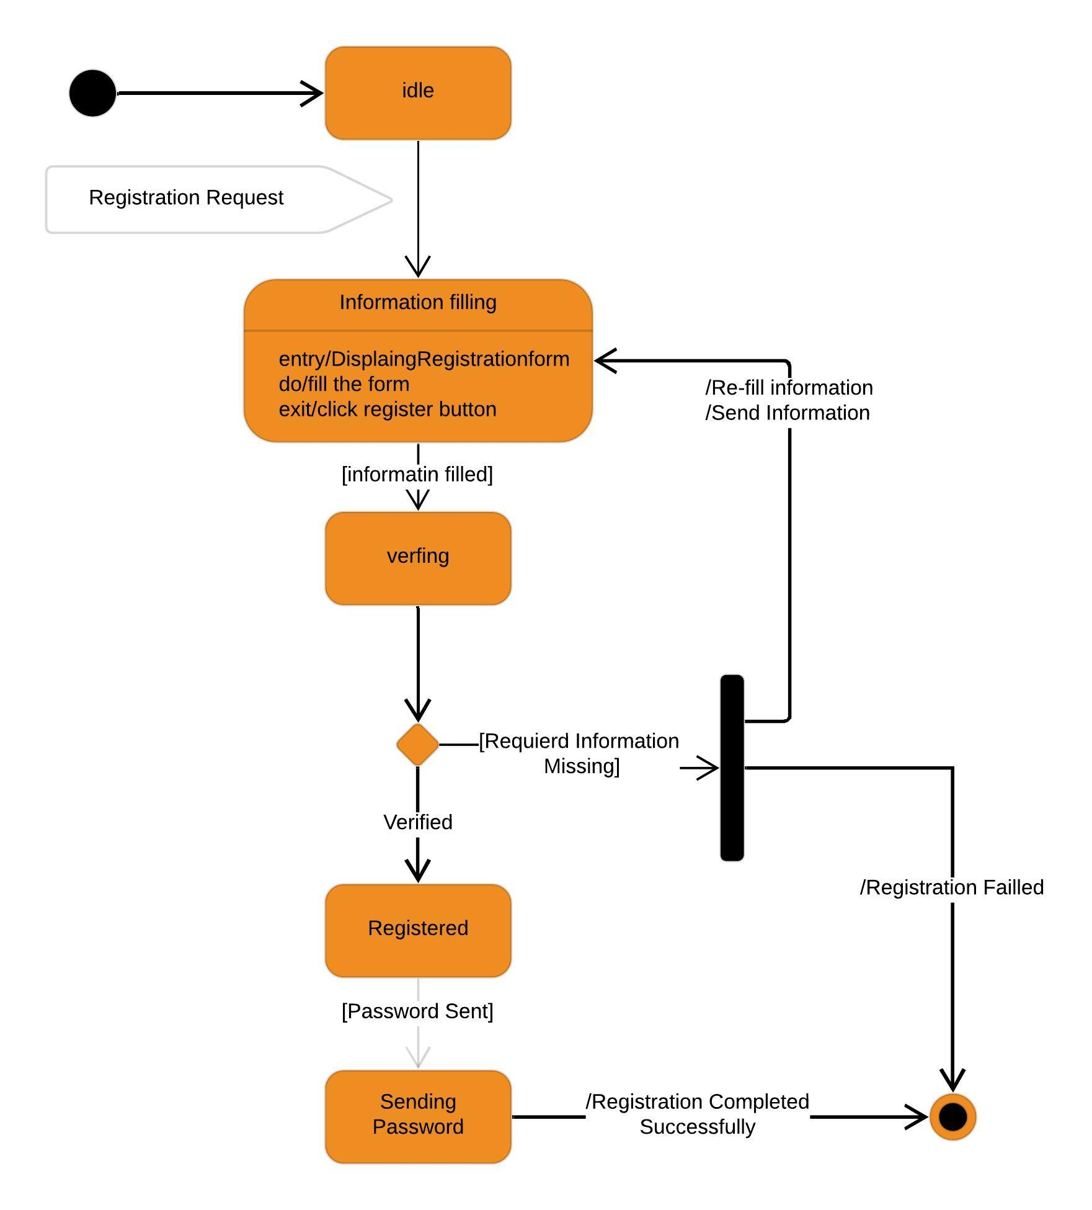

Figure 21: State diagram for registering a new account

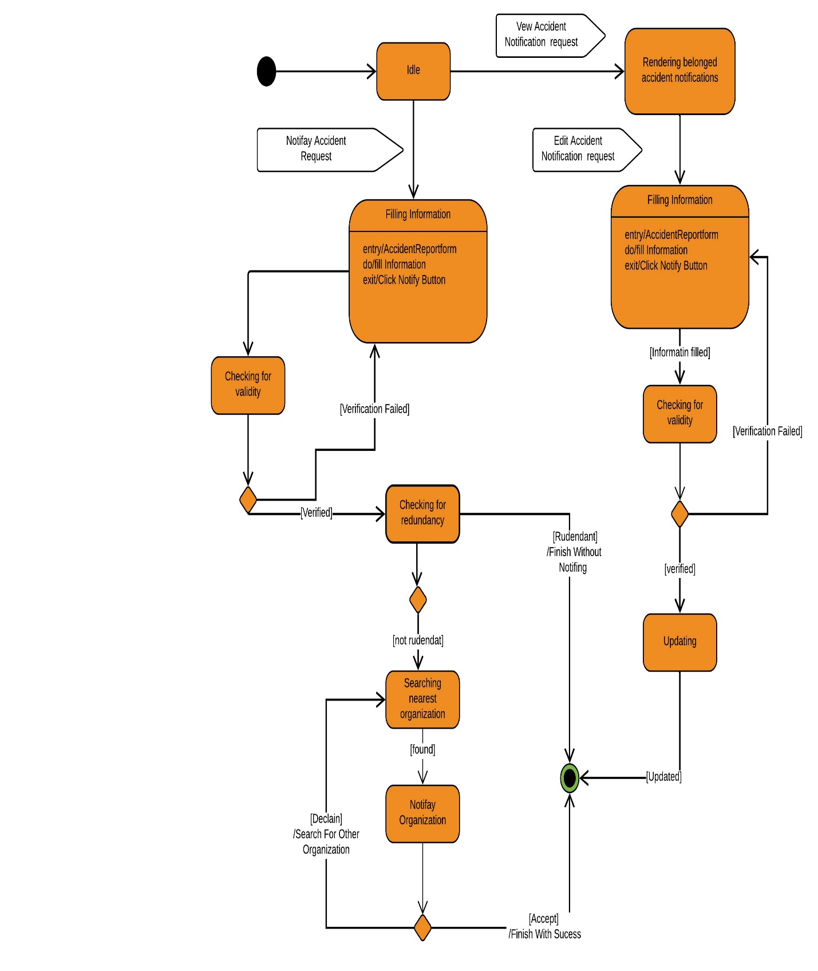

Figure 22: State diagram for notifying and editing an accident

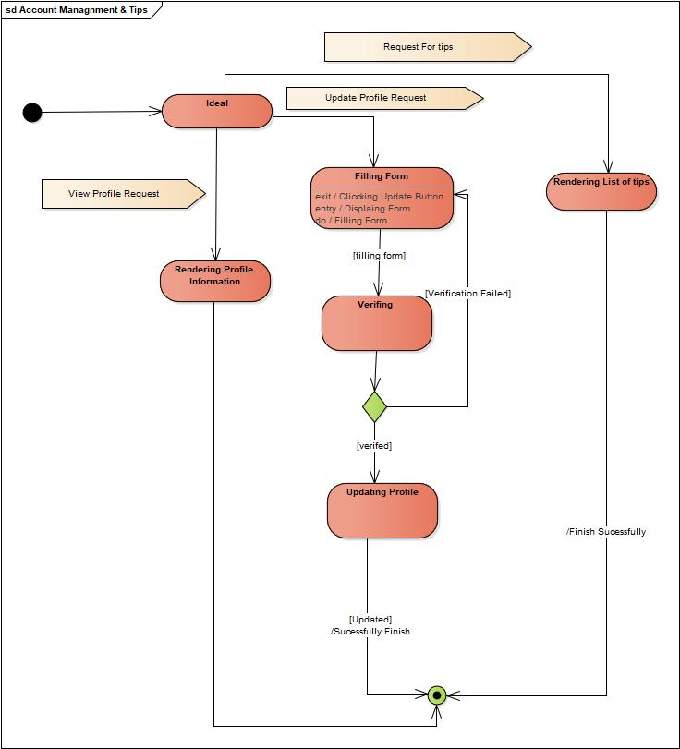

Figure 23: State diagram for account management and tips

## Class based modeling

### Class Identification

* User
* Accident Notifier
* Traffic Accident Notification
* Report
* Claim Report
* Higher Official
* Traffic Accident Investigator
* Control Room Manager
* Health Organization Administrator
* Insurance Branch Administrator
* Fire Station Administrator
* Federal Administrator
* Regional Administrator
* Zonal Administrator
* Incident Report
* Traffic Accident Record

### Class Diagram

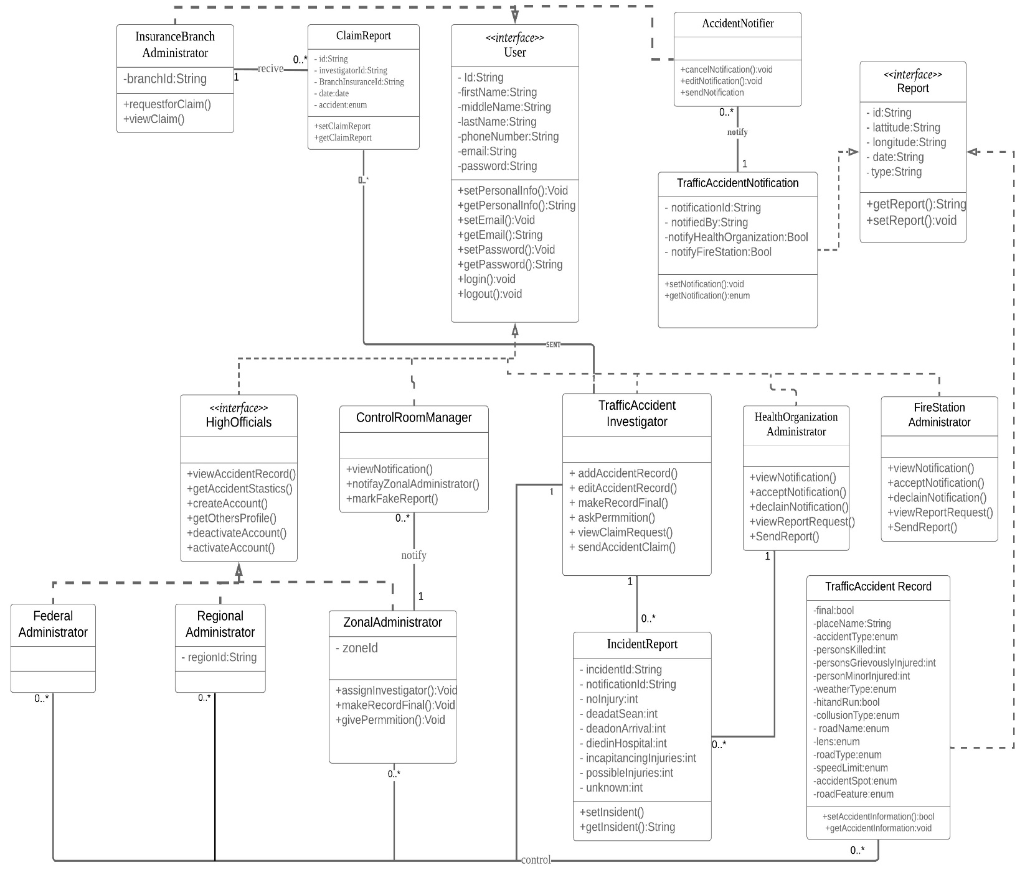

Figure 24: Class diagram for Traffic Accident Reporting System

# System Design

## Overview

The Traffic Accident Reporting platform will be designed in a way that the system will be usable, scalable and compatible. The system will be designed to be modified easily while it will keep making traffic accident reporting and data management efficient and modernized. The system will comprise a database to store information about the reports of each accident, investigations with an update each time the investigation detail changes, actors in their respective hierarchy, other stakeholders away from the organizational boundary, other service providers and additional information that is related to the field. The system also comprises ways of reporting any accidents occurring around us to the central accident management offices, saving the details of each accident and reviewing those any time, assigning investigators to handle further investigations on the accidents, reporting results of accident investigation and reviewing details of reports, locating nearby emergency service providers to help during traffic accidents, providing necessary details of accidents and reports to other stakeholders under some legal circumstances, controlling the account of the users of the system, logging accidents reports in the stakeholders’ offices and viewing tips of many importance to the users of the application. Generally, it will provide a service of handling the traffic accident system management and reporting process. The system will be a three-tier application consisting of a presentation tier for managing user interface and web server that contains all the logic for the system and database. The web server is maintained using the Node.js server, Mongo DB server is used as a back-end database and backend development will be done via JavaScript (Node.js) framework while front-end development will be done using JavaScript (Vue.js) framework and finally the mobile application development is done using flutter framework.

## System design

### System Decomposition

Accident Record Management

Tips Management

System

Accident Notification Management

User Management

### Module Description

**User Management**

* This module will manage the users account related things which are mostly done by administrators,
* All users of the system are managed by their higher administrators as per their hierarchy for every activity of them in the system

*Provided Interface -* differ as per the user and operation

*Required Interface –* each user respective homepage

*Processing*

* Creating account
* Fill in the necessary information
* Information is verified
* An appropriate page for the user based on the credentials filled will be displayed
* Activating member account
* Administrators select the account to be activated,
* Activation link will be sent to the members’ email
* The member will use the activation link to activate the account
* The activated account will be able to access the system operations
* Deactivating member account
* Administrators select the account to be deactivated
* The account detail will be updated to the inactive state
* The deactivated account will not be able to access the operations of the system
* Access Information
  + - Each user will be given a level of access that determines how much of the system they are able to access
    - Depending on the level of access the users’ privilege can be as follows
* The user profile is viewed
  + - Once the user account is created the user profile is viewed to the user and other users as per their privilege,
* Logs
  + - Different information in the system will be logged and viewed to the respective necessary users,
    - For example, the accident report logs will be displayed to the zonal administrator every time there is an accident, notification logs for the emergency service providers and other organizations also will be viewed as per their privilege and information importance,
    - These and other logs will be displayed
  + Level of access 1
* Users with the access level of one (accident notifier) can only have access to the mobile application to send accident reports to the traffic police stations, health organizations, and fire stations. They can also edit and cancel these accident reports.
  + Level of access 2
* Users with the access level of two (emergency service providers) can receive notifications during accidents, view their reports of accidents, send reports to the investigator's and edit their profile.
  + Level of access 3
* Users with the access level of three (investigators) can receive a notification when zonal traffic officers assigned them to investigate an accident. They can report accident details and investigation results, edit their personal profiles, send a request to the higher administrators as needed, logs of their reports, receive and view the reports of each accident and victim details.
  + Level of access 4
* Users with the access level of four (zone administrators) can edit their personal profile, create, activate and deactivate accounts of investigators, control room manager, and branch insurance manager. They can view accident reports from the investigators and earlier stored accident reports and analysis done by the system, give permission to the investigator to edit finalized reports, statistics of periodic accidents, and allocate investigators for new incoming accidents. They generally control the operation of investigators.
  + Level of access 5
* Users with the access level of five (regional administrators) can edit their personal account profile, create, activate and deactivate accounts of zonal administrators, receive notification of new reports, and see statistical data of the traffic accident and analysis with their access level. They generally manage the operations of the zonal traffic police.
  + Level of access 6
* Users with the access level of six (federal administrators) can edit their personal account profiles. They can create, activate and deactivate the accounts of the regional administrators. See the statistical data of the traffic accident, and access the earlier stored reports and analysis. They generally manage the overall country-level traffic accident management system and the operations of the regional administrators.

**Accident Record Management**

* This module is used to record the details of the record to the database as needed by the investigator and provide access to records

*Provided interface* – interface for managing accident records

*Required interface*­ – homepage of the user

*Processing*

* Requests
* When an investigator wants to edit his/her finalized report of the past due to some changes encountered, he/she will send a request to the zonal administrator to get access to the report,
* The zonal administrator will receive a notification that shows the request to edit,
* Allocating investigators
* Every time accidents need investigators, the zone administrator will allocate investigators,
* Investigators will be notified by their accounts
* Investigators can edit an accident report
* Change in the results of an investigation before the report has been finalized can be edited by the investigator,
* The investigators will have to ask permission from the zonal admin to edit their report if they are marked as final
* Investigators will send a request to their admin to get permission to edit their past reports
* Medical reports can be updated
  + - Every time hospitals will report the status of accident patients in their organization,
    - The medical details of that patient will be sent to the investigators,
    - If there are any changes in the medical details of the patient the hospital administrator will update the investigation group
* Accident detail and report are viewed
  + - The details of the accident which are reported will be stored in the central database,
    - These details of accidents will be viewed by the higher authorities as per their need
* Statistics is viewed
  + - The system will make statistical data out of the gathered and stored information about accidents,
    - This statistical data will be viewed to the higher authorities
* Analysis
  + - There is an analysis made about accidents like proximity analysis, daily reports which are further analyzed data about the accidents, and are displayed to the users as per their need

**Accident Notification Management**

* This module is used to manage information related to accident notification

*Provided interface* – interface for managing accident notification

*Required interface*­ – homepage of the user

*Processing*

* The user of the system that encounters accidents will fill the details of the accident and send it to the traffic police station and emergency service providers nearby
* Accident notification can be updated and canceled
* User will fill the accident details,
* The details of that accident can be updated or canceled,
* Notifications
* Different authorized stakeholders can see the accident notification. Hospital and Fire Station Administrators can see notification sent to them. Zonal traffic administrators can see this accident notification if it is approved by the control room manager.

**Tips Management**

* This module is used to create the content of the tips that will be provided to the users and how they will be provided to the user.

*Provided interface* – interface for filling in tips

*Required interface* – users interface to get the tips

*Processing*

* The content
  + - The content of the tips will be filled,
    - Once filled the tips will be inserted to the database online and locally,
    - Then the system will pull the tips to the user
* The showing pattern
  + - The filled-in tip data will be pulled to the user,
    - These tips will be viewed
* Tips
* The tips provided for users are viewed

## Architecture of the system

### Architectural Style and Pattern

Architectural Style

* Language-Based - Object-Oriented

The system divides its task among individuals of reusable objects, which communicate to each other in order to perform the full functionality of the system.

* Layered - Client Server

It is a distribution of structure that partitions tasks or workloads between the providers of resource of service, called server, and service sequester called client

* Data Flow - Batch-Sequential

Architectural pattern

Model-View-Controller (MVC)

MVC is an architecture, which helps in developing the web application in the most efficient way because it separates an application into three main logical components.

Model:

The model corresponds to all the data-related logic that the user works with.

View:

The view component is used for all the UI logic of the application.

Controller:

It is used in order to handle the request from the user by communicating the view with the model.

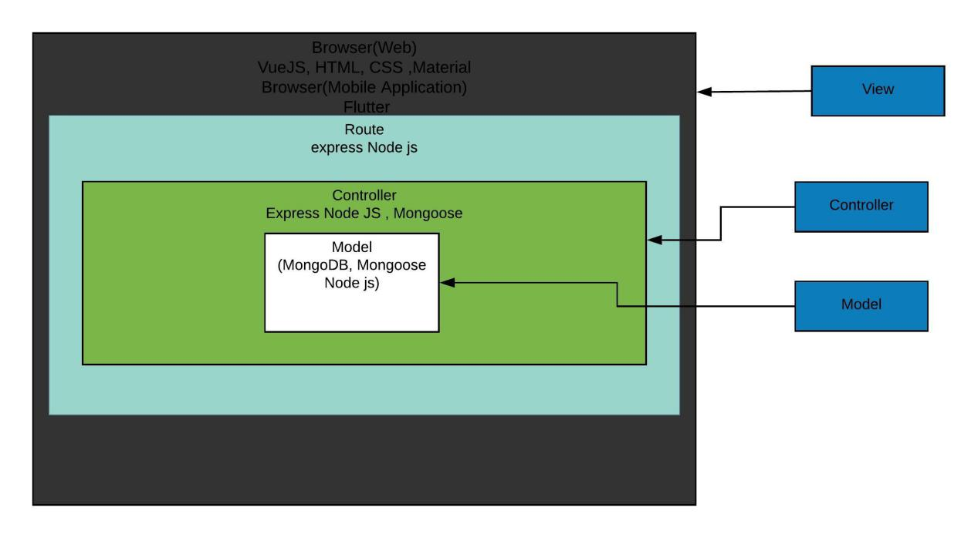

Figure 25: MVC view of the system

### Component Diagram

The component diagram shows a modular part of a computer system, which is a piece of information that the system uses or creates. The following component diagram shows how the system implements modularity and how each component communicates to each other in order to help the system to perform its full functionality.

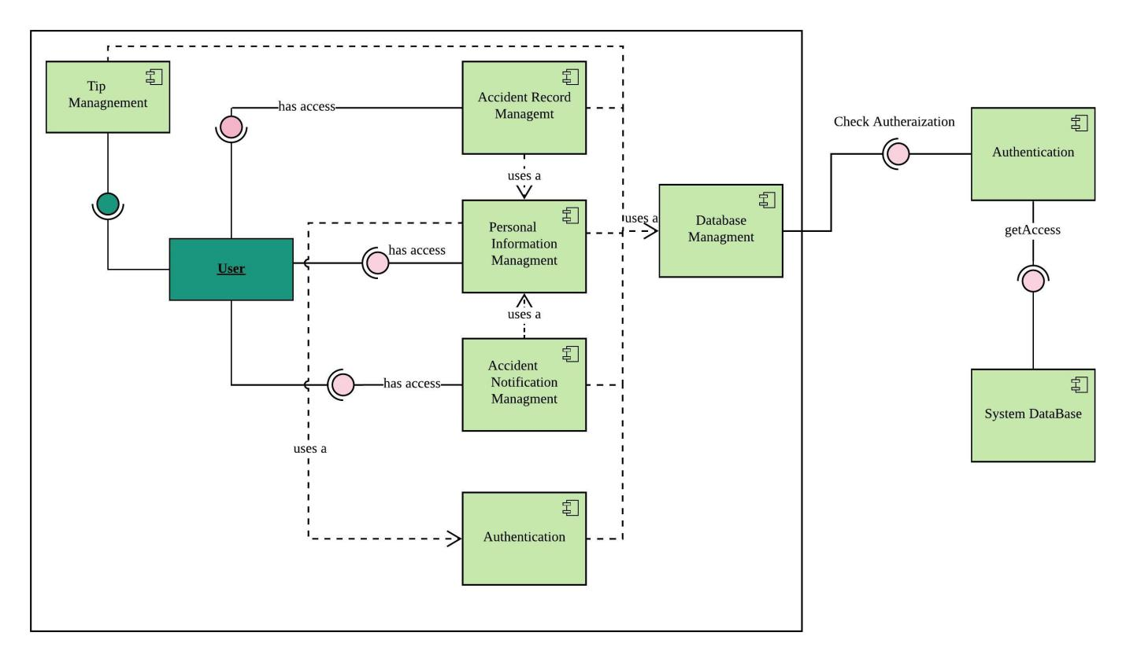

Figure 26: Component Diagram for Traffic Accident Reporting System

### Component description

**Accident Record Management**- This component is responsible for the management of accident records which includes the following tasks

* Adding new Accident record
* Editing not finalize record
* Finalize Accident record
* Give permeation to edit finalize records
* View Accident Records and Statistics

**Personal information management**- This component is responsible for managing all information, which is related to users’ profiles, related to TARS. It includes creating, editing and deleting accounts.

System Database- This component is responsible for saving information which is related to TARS like Account information, Traffic Accident Notification information, Traffic Record information, claim information and service provider information.

**Authentication** - This component is used in order to guard the system.

**Accident Notification Management**- This component is responsible for managing accident notification information like Viewing, Adding, Editing and Deleting Accident Notification information.

**Tips Management** - This component is responsible for the management of different tips, which are getting by the user of TARS mobile application.

**Database Management** - This component is the collection of different DBMS, which helps the system to communicate with the system database.

**System Database** - This component is responsible for storing the data structure of TARS.

### **Deployment Diagram**

A deployment diagram shows how the physical system will look when all components put together. It consists of nodes represented on the diagram, with each node representing part of the functionality of the system.

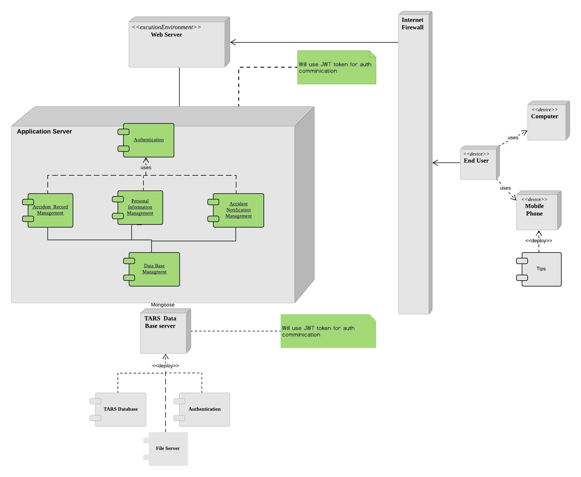

Figure 27: Deployment Diagram for Traffic Accident Reporting System

## Database Design

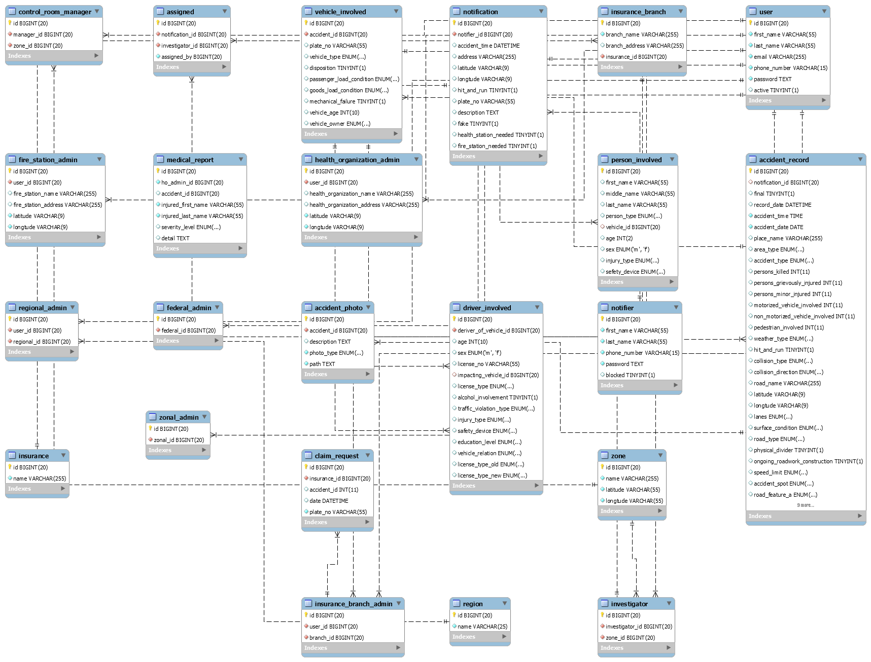

Figure 28: ER Diagram for Traffic Accident Reporting System

## User Interface Design

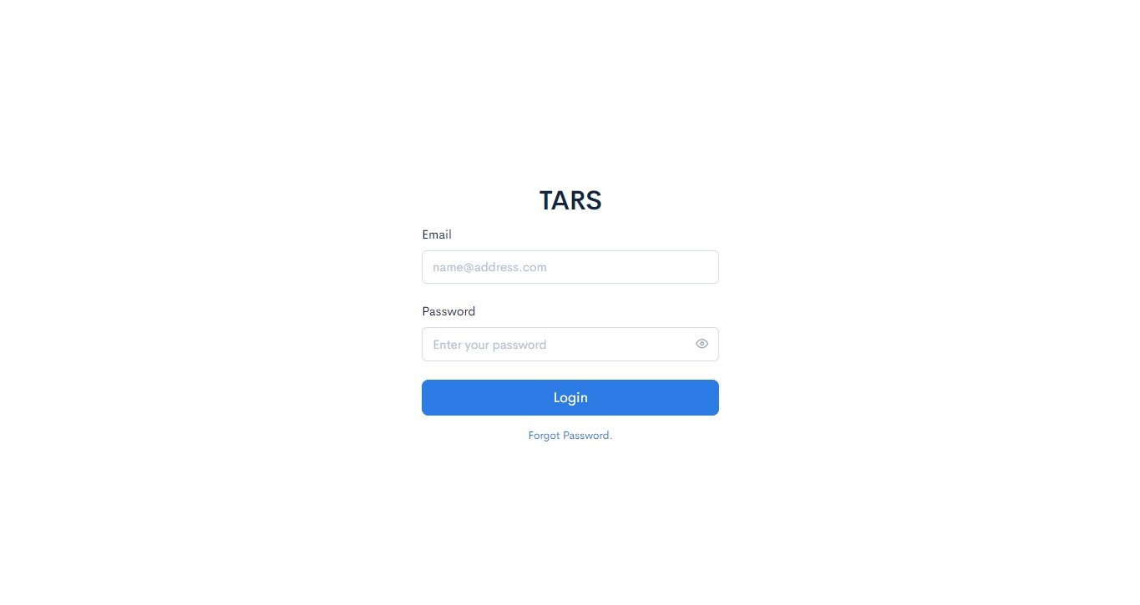

Figure 29: User Interface Design for Login Page for Administrators and Investigators

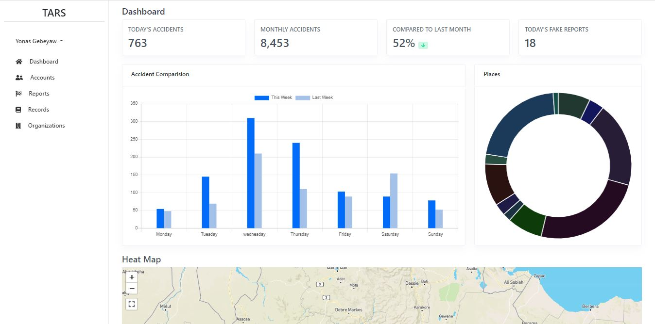

Figure 30: Dashboard User Interface for Admin

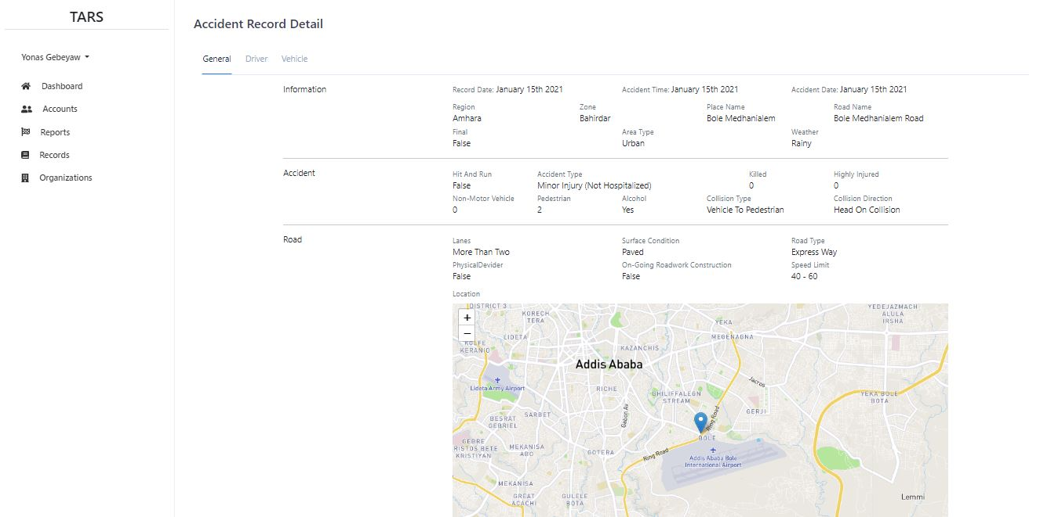

Figure 31: User Interface for Accident Record Detail

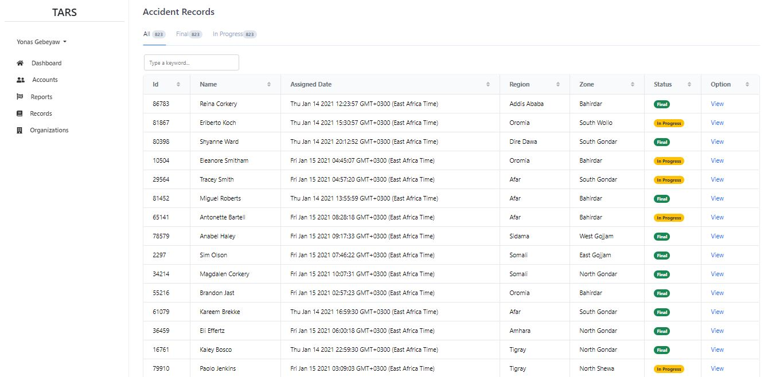

Figure 32: User Interface for Viewing Accident Records List for Admin

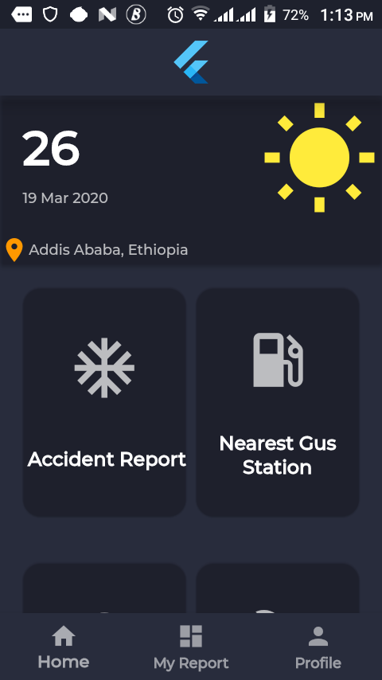

Figure 33: Mobile application user interface for reporting traffic accident

# Implementation and Testing

## Implementation

This phase of development contains codes that convert specification and design architecture to usable software. The software includes backend development, which stores and serves data to the user, frontend, which displays and converts backend data to user friendly format and android application for sending accident notification.

### Front-End Implementation

**Code for viewing record detail with sample data. File Name: recordDetail.vue**

<template>

<div class="container-fluid py-3 my-3">

<div>

<h4 class="gray-700">Accident Record Detail</h4>

</div>

<div class="record-container mx-auto p-3">

<ul class="nav nav-tabs nav-overflow header-tabs" role="tablist">

<li class="nav-item" role="presentation">

<a

class="nav-link active"

id="pills-home-tab"

data-bs-toggle="pill"

href="#pills-home"

role="tab"

aria-controls="pills-home"

aria-selected="true"

>

General

</a>

</li>

<li class="nav-item" role="presentation">

<a

class="nav-link"

id="pills-profile-tab"

data-bs-toggle="pill"

href="#pills-profile"

role="tab"

aria-controls="pills-profile"

aria-selected="false"

>

Driver

</a>

</li>

<li class="nav-item" role="presentation">

<a

class="nav-link"

id="pills-contact-tab"

data-bs-toggle="pill"

href="#pills-contact"

role="tab"

aria-controls="pills-contact"

aria-selected="false"

>

Vehicle

</a>

</li>

</ul>

<div class="tab-content" id="pills-tabContent">

<div

class="tab-pane fade show active"

id="pills-home"

role="tabpanel"

aria-labelledby="pills-home-tab"

>

<!-- -->

<General :general="record.general" />

</div>

<div

class="tab-pane fade"

id="pills-profile"

role="tabpanel"

aria-labelledby="pills-profile-tab"

>

<div class="container">

<div

v-for="driver in record.driversInvolved"

:key="driver.licenseNumber"

class="driver text-capitalize p-2"

>

<!-- -->

<Driver :driver="driver" />

<hr />

</div>

</div>

<!-- driver end -->

</div>

<div

class="tab-pane fade"

id="pills-contact"

role="tabpanel"

aria-labelledby="pills-contact-tab"

>

<div class="vehicle-container mt-3">

<div class="container">

<div

v-for="vehicle in record.vehiclesInvolved"

:key="vehicle.plateNumber"

class="vehicle text-capitalize p-2"

>

<!-- -->

<Vehicle :vehicle="vehicle" />

<hr />

</div>

</div>

<!-- vehicle end -->

</div>

</div>

</div>

</div>

</div>

</template>

<script>

import moment from "moment";

import General from "./recordDetailTab/general";

import Driver from "./recordDetailTab/driverInvolved";

import Vehicle from "./recordDetailTab/vehicleInvolved";

export default {

name: "RecordDetail",

components: {

General,

Driver,

Vehicle,

},

data() {

return {

recordId: this.$route.params.id,

record: {

general: {

// Infromation

region: "Amhara",

zone: "Bahirdar",

final: false,

recordDate: moment().format("MMMM Do YYYY"),

accidentTime: moment().format("MMMM Do YYYY"),

accidentDate: moment().format("MMMM Do YYYY"),

placeName: "Bole Medhanialem",

roadName: "Bole Medhanialem road",

areaType: "Urban",

weatherType: "Rainy",

// Accident

accidentType: "minor injury (not hospitalized)",

personsKilled: 0,

highlyInjuredPeople: 0,

minorInjuredPeople: 0,

nonmotorizedVehicleInvolved: 0,

pedestrianInvolved: 2,

alcoholInvolvement: "Yes",

hitAndRun: false,

collisionType: "vehicle to pedestrian",

collisionDirection: "head on collision",

// road

accidentLocation: {

type: "point",

coordinates: [8.9881, 38.79124],

},

lanes: "more than two",

surfaceCondition: "paved",

roadType: "express way",

physicalDevider: false,

ongoingRoadworkConstruction: false,

speedLimit: "40 - 60",

//traffic

accidentSpot: "market/commercial area",

roadFeatureA: "straight road",

roadFeatureB: "none",

roadPotHoles: false,

roadSteepGradient: true,

roadJunction: "round about",

trafficControlType: "uncontrolled",

pedestrianFootpath: true,

pedestrianFootbridge: false,

pedestrianZebraCrossing: true,

},

vehiclesInvolved: [

{

plateNumber: "12345",

plateCode: 3,

plateCodeRegion: "Addis Ababa",

vehicleType: "Bus",

disposition: false,

passengerLoadCondition: "Overloaded/Hanging",

goodsLoadCondition: "Normally Loaded",

mechanicalFailure: false,

vehicleAge: 5,

vehicleOwner: "governmental organization",

},

],

driversInvolved: [

{

driverName: "Yonas Gebeyaw",

licenseNumber: "541287/20",

age: 22,

sex: "Male",

educationLevel: "above preparatory",

vehicleRelation: "owner",

licenseTypeOld: "4",

licenseTypeNew: "automobile",

alcoholInvolvement: "no",

trafficRuleViolationType: "Over speeding",

injuryType: "Unknown",

safetyDevice: "Seat Belt",

},

],

},

};

},

};

</script>

### Back-End Implementation

**Middleware to check if the user is authenticated**

const jwt= require("jsonwebtoken")

module.exports=(req, res, next)=>{

try {

const token= req.headers.authorization.split(" ")[1]

const decoded= jwt.verify(token, process.env.JWT_KEY)

req.userData = decoded

next()

} catch (error) {

console.log("token auth failed")

return res.status(401).json({

message: 'Auth failed',

})

}

}

**Middleware to check if the user is admin[Forwarded from Kaleab]**

const Users=require("../models/userModel");

module.exports=(req, res, next)=>{

try {

Users.findById(req.userData.userId).exec()

.then(user=>{

if(user.admin){

next();

}

else{

console.log("user is not admin")

res.status(500).json({

message: 'user is not admin',

})

}

}).catch(err=>{

console.log(err)

res.status(500).json({

error: err,

message: "check admin failed-user not found"

})

})

} catch (error) {

console.log("check admin middleware failed")

return res.status(401).json({

message: 'Access Restricted',

})

}

}

**Code for Accident Record Model**

const mongoose=require("mongoose")

const AutoIncreament=require("mongoose-sequence")(mongoose)

const Notification=require("./notificationModel")

const Investigator=require("./userModel")

const Zone=require("./zoneModel")

const Region=require("./regionModel")

const date=new Date()

const AccidentRecordSchema= mongoose.Schema({

_id: mongoose.Schema.Types.ObjectId,

recordId:{

type:Number,

default:0

},

notificationId:{

type:mongoose.Schema.Types.ObjectId,

ref: 'Notification',

required:true

},

investigatorId:{

type: mongoose.Schema.Types.ObjectId,

ref:'Investigator',

required: true

},

region:{

type:String,

required: true

},

zone:{

type:String,

required: true

},

final:{

type: Boolean,

default: false

},

recordDate:{

type: Date,

default: Date.now()

},

accidentTime:{

type: Date,

default: date.getTime()

},

accidentDate:{

type: Date,

default: Date.now()

},

placeName:{

type:String,

default: "not_filled"

},

areaType:{

type: String,

enum: ['Rural', 'Urban'],

required: true

},

accidentType:{

type: String,

enum:['fatal', 'grievously injured (hospitalized)', 'minor injury (not hospitalized)', 'non-injury','other'],

required: true

},

personsKilled:{

type: Number,

default: 0,

},

highlyInjuredPeople:{

type:Number,

default: 0

},

minorInjuredPeople:{

type:Number,

default:0

},

motorizedVehicleInvolved:{

type:Number,

default:0

},

nonmotorizedVehicleInvolved:{

type:Number,

default:0

},

pedestrianInvolved:{

type:Number,

default:0

},

weatherType:{

type:String,

enum:['Sunny/Clear', 'Rainy', 'Foggy/Misty', 'Hail/Sleet', 'Other'],

required:true

},

alcoholInvolvement:{

type:String,

enum:['yes', 'no', 'unknown'],

required:true

},

hitAndRun:{

type:Boolean,

default: false

},

collisionType:{

type:String,

enum:['vehicle to vehicle', 'vehicle to pedestrian', 'vehicle to bycycle', 'vehicle to animal', 'hit parked vehicle', 'hit fixed/stationary object'],

required:true

},

collisionDirection:{

type:String,

enum:['hit from back', 'hit from side', 'run off road', 'vehicle overturn', 'head on collision', 'other'],

required:true

},

roadName:{

type:String

},

accidentLocation:{

type:{

type:String,

default: 'point'

},

coordinates:{

type:Array,

default:[0,0]

}

},

lanes:{

type:String,

enum:['two or less','morethan two'],

required:true

},

surfaceCondition:{

type:String,

enum:['paved', 'unpaved'],

required:true

},

roadType:{

type:String,

enum:['expressway', 'national highway', 'state highway', 'other roads'],

required:true

},

physicalDevider:{

type:Boolean,

default: false

},

ongoingRoadworkConstruction:{

type:Boolean,

default: false

},

speedLimit:{

type:String,

enum:['< 40', '40 - 60', '60 - 80', '> 80', 'not available'],

required:true

},

accidentSpot:{

type:String,

enum:['residential area', 'institutional area', 'market/commercial area', 'open', 'other'],

required:true

},

roadFeatureA:{

type:String,

enum:['straight road', 'curved road'],

required:true

},

roadFeatureB:{

type:String,

enum:['bridge', 'culvert', 'none'],

required:true

},

roadPotHoles:{

type:Boolean,

default: false

},

roadSteepGradient:{

type:Boolean,

default: false

},

roadJunction:{ [Forwarded from Kaleab]

type:String,

enum:['T', 'Y', 'four arm', 'staggered', 'round about']

},

trafficControlType:{

type:String,

enum:['traffic light signal', 'police control', 'stop sign', 'flashing signal', 'uncontrolled'],

required:true

},

pedestrianFootpath:{

type:Boolean,

default: false

},

pedestrianFootbridge:{

type: Boolean,

default: false

},

pedestrianZebraCrossing:{

type:Boolean,

default: false

}

},{timestamps:true})

AccidentRecordSchema.plugin(AutoIncreament, {inc_field: 'recordId'})

module.exports=mongoose.model("AccidentRecord", AccidentRecordSchema)

## Testing

According to steps in software development life cycle (SDLC) framework testing is performed next to implementation. Testing contribute an important role in identifying whether the constructed system is working as per requirement stated before. This project have been tested using manual testing techniques.

The project has been tested for:

* Code Review: System’s source code has been checked carefully in-order to remove lots of Architectural and implementation problems.
* Unit testing: Individual module have been tested
* Integration Testing : After testing individual modules, combined modules have been tested in order to check there ability to work together
* System Testing: In this testing phase, we checked whether the whole system works as per requirement or not.

In order to test the system the following sample test cases have been prepared to test the system.

|  |  |  |  |  |  |
| --- | --- | --- | --- | --- | --- |
| Test case Id | Test Name | Description | Input | Expected result | Remark |
| 1 | Registration | The register functionality of the system tested by providing it with registration credentials | Valid Registration credentials | The system performs the ordered task properly | The system performs the ordered task properly |
| 2 | Registration | The register functionality of the system tested by providing it with registration credentials | Invalid inputs, inappropriate values | The user is prompted to reenter correct login credential again | The user is prompted to reenter correct login credential again |

|  |  |  |  |  |  |
| --- | --- | --- | --- | --- | --- |
| Test Id | Test Name | Description | Input | Expected Result | Remark |
| 3 | Login | This login functionality of the system tested by providing it with login credentials | Correct Email and Password | Home page based on the credential information provided to user | System provides relevant homepage to the user |
| 4 | Login | This login functionality of the system tested by providing it with login credentials | Incorrect Email and Incorrect password  Incorrect Email and correct password  Correct Email and incorrect password | The user is prompted to reenter login all login credentials (i.e password and email )  again | User is prompted to reenter correct login credentials. |

|  |  |  |  |  |  |
| --- | --- | --- | --- | --- | --- |
| Test case Id | Test Name | Description | Input | Expected  result | Remark |
| 5 | Notify Accident | Notify Accident tested by providing it with the information used to notify accident | Correct Information | The Accident reported According to the input |  |
| 6 | Notify Accident | Notify Accident tested by providing it with the information used to notify accident | Empty input | The Accident Reported With Default value to the attribute |  |

|  |  |  |  |  |  |
| --- | --- | --- | --- | --- | --- |
| Test Case Id | Test Name | Description | Input | Expected result | Remark |
| 7 | Add Accident Record | Adding Accident report functionality tested by providing the information used in-order to notify accident. | Correct information | The Accident recorded to the central data base | The system recorded the accident and sent success message to the Investigator |
| 8 | Request Claim Report | Adding Accident report functionality tested by providing the information used in-order to notify accident. | Invalid information  Empty information | The investigator prompted to reenter the attribute | The system sent error message and prompted the investigator to reenter the attribute |

|  |  |  |  |  |  |
| --- | --- | --- | --- | --- | --- |
| Test Case Id | Test Name | Description | Input | Expected result | Remark |
| 9 | Edit Accident Report | Editing Accident report functionality tested by providing information and request used to edit accident record. | Record Id of Editable record. | The Edit page based on the request ID provided to the user | The system provided the edit accident page to the user |
| 10 | Edit Accident Report | Editing Accident record functionality is tested by providing information and request used to edit accident record. | Record Id of not editable record | The user provided with error message sayied the record was marked as final | The system sent error message about the final record. |

# Conclusion and Future Work

The main aim of this project was to develop a web based accident notification reporting and record management system that automates the process of notifying an accident, investigating and generating accident report and statistics. Through the project development phases, we have developed a software that covers essential parts of the whole process basing our development on the requirement identified as crucial for the automation of the process. Even though we have tried to incorporate the essential parts, we believe that there are some features that need to be included in the future. Some of them are:

* Using machine learning algorithms to predict accident locations and formulate generalizations for various organizations to reduce accidents. These includes road authority and statistics authority.
* Include court rulings information
* Improve user experience with better UI design
* Include other report and statistics types to better understand accident reports and records

# References

|  |  |
| --- | --- |
| [1] | "Data Considerations," [Online]. Available: https://ec.europa.eu/transport/road_safety/specialist/knowledge/pedestrians/crash_characteristics  _where_and_how/data_considerations_en. |
| [2] | "Road Traffic Injuries," World Health Organization, 7 December 2018. [Online]. Available: https://www.who.int/news-room/fact-sheets/detail/road-traffic-injuries. |
| [3] | "Ethiopia introduces pedestrian penalties to cut road traffic accident," NewBusinessEthiopia , 14 August 2017. [Online]. Available: https://newbusinessethiopia.com/health/ethiopia-introduces-pedestrian-penalties-to-cut-road-traffic-accident/. |
| [4] | "Waterfall model," 30 August 2019. [Online]. Available: https://en.wikipedia.org/wiki/Waterfall_model. |
| [5] | F. Samson, "Analysis of Traffic Accident In Addis Ababa: Traffic Simulation," 2006. |
| [6] | J. SODIKOV, "ROAD TRAFFIC ACCIDENT DATA ANALYSIS AND VISULAIZATION IN R," 2018. |
| [7] | Panagiotis Papaioannou, Socrates Basbas, Dr Alexandros Kokkalis , "DESIGN OF A TRAFFIC ACCIDENT MANAGEMENT SYSTEM (TAMS), FOR THE GREEK NATIONAL IDGHW AY SYSTEM, USING GIS TECHNOLOGY". |
| [8] | M. Amer Khan, Abdulla Salim Al Kathairi & Atef M. Garib , "A GIS based traffic accident data collection, referencing and analysis framework for Abu Dhabi". |
| [9] | "The road traffic crash data system in Kenya". |
| [10] | Dr. Jaehoon SUL, Dr. Lyoong OH , "Road Accident Data Collection and Management System in Korea," [Online]. |
| [11] | Hamid M. Ali, Zainab S. Alwan, "Car Accident Detection and Notification System Using Smart Phone". |
| [12] | M. o. R. T. a. Highways, "Revised Road Accidents Data Recording and Reporting Formats," [Online]. |
| [13] | T. A. S. a. A. D. Federal Police Commission, "የ2011 የትራፊክ አደጋ ስታትስቲክስ ". |
| [14] | Raphael Stanislaw, Tomasz Lech, Marek Jacek, "Drivers reaction time in a simulated complex road incident". |

# Appendix

**ፌደራል ፖሊስ - ትራፊክ አደጋ ስታትስቲክስ**

1. አሁን የምትጠቀሙበት የትራፊክ አደጋ አያያዝ መንገድ ምን ይመስላል?
2. የትራፊከ አደጋ መረጃ ከየት እና በምን የጊዜ ልዩነት ታገኛላችሁ?
3. አሁን በምትጠቀሙበት ሲስተም ምን አይነት ጥቅም አግኝታችሁበታል? ችግሮቹን ምን ምን ናቸው?
4. የትራፊክ አደጋ መረጃዎቸን የምትመዘግቡበት ሪፖርት የሚደረግበት አካሄዱን ቢያብራሩልን?
5. የመረጃ መመዝገቢያ ቅጾች ምን ይመስላሉ?
6. የሰበሰባችሁትን የስታስቲክስ መረጃ ለምን ጥቅም ታውሉታላችሁ?
7. መረጃው በተፈለገው ጊዜ በማይደርስበት ወቅት ምን አይነት አማራጭ ትጠቀማላችሁ?
8. የመረጃው ተጠቃሚዎቸ እነማን ናቸው? ተጠቃሚዎች መረጃውን የሚያገኙበት አሰራር አለ? ካለስ ምን ይመስላል?
9. ከኢንሹራንስ ኩባያዎች ጋር ያላችሁ ግንኙነት ምን ይመስላል?
10. ከሌሎች የግልም ሆነ የመንግስት መስሪያ ቤቶች ከትራፊክ አደጋ ጋር በተያያዘ መረጃ ለማግኘት ወይም ለማጣራት ከየትኞቹ ጋር ትገናኛላችሁ?
11. ከትራፊክ አደጋ ጋር በተያያዘ ለአደጋው ግብአት የሚሆን ያገኛችሁትን መረጃ በምን መንገድ ትጠቀሙበታላችሁ?
12. ከላይ ከጠቀሳችኋቸው መስሪያ ቤቶች ጋር በምን መንገድ ትገናኛላችሁ?
13. አሰራሩን ለማዘመን ሙከራ ነበር; ካልተሳካ ምክንያቱን ቢያብራሩልን?
14. አዲስ የሚሰራው ሲስተም ምን አይነት ቢሆን (ቢካተት) የምትሉት ነገር ካለ?

**ለኢትዮጵያ መንገድ ትራንስፖርት ባለስልጣን**

1. ከትራፊክ አደጋ ጋር የተያያዙ መረጃዎችን የምታገኙበትና የምታዘጋጁበት መንገድ ምን ይመስላል?
2. መረጃውን ከየት እና በምን የጊዜ ልዩነት ታገኛላችሁ?
3. አሁን የምትጠቀሙበት የአሰራር ዘዴ ምን ይመስላል? ምን አይነት ጥቅሞች አሉት? ጉዳቶቹስ?
4. የምታገኙትን መረጃ ለምን አገልግሎት ትጠቀሙበታላችሁ?
5. የመረጃው ሌሎች ተጠቃሚዎች እነማን ናቸው?
6. ከሌሎች ተቋማት ጋር ምን አይነት ግንኙነት አላችሁ?
7. የአሽከርካሪዎችን መረጃ ፣ የመኪና ባለቤትነት መረጃ እንዲሁም ሌሎች ከትራፊክ አደጋ ጋር የተያያዙ መረጃዎችን በምን አይነት መልኩ ታደራጃላችሁ? እነዚህን መረጃዎች ለሚፈልጉ አካላትስ በምን መንገድ ታቀርባላችሁ?
8. አሁን ካለው አሰራር በተጨማሪ ከላይ ከጠቀሳችኋቸው ተቋማት ጋር በተያያዝ ምን አይነት የመረጃ መለዋወጫ ወይም መገናኛ መንገድ ቢኖር ትመርጣላችሁ?

**ለትራፊክ ፖሊስ**

1. የትራፊክ አደጋ ሲከሰት በምን መንገድ ትሰማላችሁ? እንደሰማችሁ መጀመሪያ የምታደርጉት ነገር ምንድን ነው?
2. እናንተ ተደራሽ ባልሆናችሁባቸው አካባቢዎች የሚከሰቱ አደጋዎችን ማህበረሰቡ ለእናንተ ሪፖርት ለማድረግ ተባባሪ ነው?
3. የትራፊክ አደጋ በሚደርስበት ጊዜ አደጋውን ለምርመራ ክፍል የምታሳውቁበት መንገድ ምን ይመስላል?
4. የሰው አካል ጉዳት እንዲሁም የእሳት አደጋ ሲከሰት በፍጥነት ህክምና እንዲያገኝ ምን አይነት አሰራር ትጠቀማላችሁ? አሰራሩ ምን አይነት ችግሮች አሉበት?
5. ከላይ የተጠቀሱት ግንኙነቶች በምን መንገድ ቢዘምን ስራውን ሊያቀላጥፈው ይችላል

**የትራፊክ አደጋ ምርመራ ክፍል**

1. የትራፊክ አደጋ በደረሰ ጊዜ በምን መልኩ ወደ እናንተ ይመጣሉ?
2. አደጋው በደረሰበት ቦታ ሂዳችሁ ምን አይነት ምርመራዎችን ታደርጋላችሁ?
3. ከአደጋው ጋር በተያያዝ የተገኙ መረጃዎችን በምን መልኩ ትመዘግባላችሁ? የመረጃውንስ አይነት እንዴት ትቆጣጠራላችሁ?
4. ከእናንተ በተጨማሪ ተጨማሪ መረጃ ከየት ተሰበስባላችሁ? ሌሎች የሚሳተፉ ትቋማትስ እነማን እንዲሁም የሚሳተፉበት መንገድ ምን ይመስላል?
5. የአደጋውን መረጃ በምን የጊዜ ልዩነት፤ እንዴት፤ እንዲሁም ለማን ትልካላችሁ?
6. መረጃ ለማግኘት ጊዜ የሚወስዱ ጉዳዮችን በምን መልኩ ታቀናጃላችሁ?
7. አሁን ያለው የአሰራር ሁኔታ ምን አይነት ችግሮች አሉበት?
8. መስሪያ ቤቱ የእናንተን ስራ ለመቆጣጠር የሚጠቀመው አሰራር ምን አይነት ነው?
9. በአጠቃላይ ይህንን አሰራራችሁን ለማዘመን ምን አይነት ዘመናዊ መንገድ ቢፈጠር ትላላችሁ?

**ኢንሹራንስ**

1. ከትራፊክ አደጋ ጋር በተያያዘ ለደንበኞቻችሁ የምታቀርባችሁ አገልግሎቶች ለማቀላጠፍ ከትራፊክ አደጋ ተቆጣጣሪዎች ጋር እንዲሁም ሌሎች የሚመለከቷቸው አካላት ጋር በምን መልኩ ትሰራላችሁ? የመረጃ ልውውጣችሁስ ምን ይመስላል?
2. ከትራፊክ አደጋ ጋር በተያያዘ ከሚመለከታቸው መስሪያ ቤቶች ምን አይነት መረጃዎችን ትፈልጋላችሁ?
3. የሚያስፈልጋችሁን መረጃዎች ለማግኘት ከየትኞቹ መስሪያ ቤቶች ጋር በጋራ ትሰራላችሁ?
4. የመረጃ ልውውጡን ለማዘመን ምን አይነት ዘመናዊ መንገድ ቢፈጠር ትላላችሁ?

**ድንገተኛ አደጋ (ህክምና ቦታዎች፣ ድንገተኛ እሳት አደጋ መከላከያ እና መቆጣጠሪያ)**

1. በትራፊክ አደጋ ምክንያት ወደ እናንተ የሚመጡ ሰራዎችን በምን መልኩ ታከናውናላችሁ?
2. ችግሮቹን በፍጥነት ለመፍታት ከሌሎች አካላት ጋር ምን አይነት አሰራር አላችሁ?
3. አደጋዎች በሚፈጠሩበት ጊዜ እንድታውቁ የሚደረግበት አሰራር አለ? ካለ ምን አይነት ነው? ችግሮቹስ ምንድን ናቸው?
4. ስለ አደጋው ለሚመለከተው የፖሊስ መስሪያ ቤት አጠቃላይ ሪፖርት የምታደርጉበት መንገድ ምን ይመስላል?
5. የመረጃ ልውውጡ በምን አይነት መንገድ ቢሆን የተሻለ ነው ብለው ያስባሉ?
6. **እድሜ** ____________
7. **የነዋሪነት ሁኔታ**  አዲስ አባባ ከአዲስ አባባ ዉጪ

**ማስገንዘቢያ**፡- በመጀመሪያ ይህን መጠይቅ ለመሙላት ስለተባበሩን እያመሰገንን ይህ የመጠይቅ ወረቀት በአዲስ አበባ ሳይንስና ቴክኖሎጂ ዩኒቨርሲቲ በሶፍትዌር ምህንድስና ትምህርት ክፍል ያሉ ተመራቂ ተማሪዎች ችግር ፈቺ እና ለማህበረሰብ አገልግሎት እንዲውል ዘንድ ለሚሰራ ፕሮጀክት ህብረተሰቡን ያማከለ እና የህብረተሰቡን ችግር እንዲፈታ ለህብረተሰቡ የተዘጋጀ መጠይቅ ነው፡፡ በመሆኑም እዚህ ላይ የሚመልሱት መልስ ለፕሮጀክቱ ግብዓት ብቻ እንዲውል ታስቦ የተዘጋጀ መጠይቅ ስለሆነ ወረቀቱን ሲሞሉልን በግልፅነት፣ በቅንነት እንዲሁም በእውነተኛነት እንዲሞሉልን እየጠየቅን እርስዎ የሚመልሱት መልስ ወደፊት ፕሮጀክቱ ሲያልቅ እና ስራ ላይ ሲውል ውጤቱን እንደሚያዩት በማመን ትክክለኛ ምላሽ እንዲሰጡን በአክብሮት እንጠይቃለን፡፡

**ለህዝብ**

1. የመኪና ባለንብረት ነዎት?

አዎ አይደለሁም

1. የመኪና አሽከርካሪ ነዎት?

አዎ አይደለሁም

1. የዘመናዊ ስማርት ስልክ ተጠቃሚ ነዎት?

አዎ አይደለሁም

1. የትራፊክ አደጋዎችን በመከላከል ሂደት ውስጥ ህዝቡን ለማሳተፍ ምቹ ሁኔታዎች አሉ ብለው ያምናሉ?

የትራፊክ አደጋን ማሳወቂያ ሞባይል አፕሊኬሽን አለ አዎ የለም

የሞባይል መልዕክት መቀባያ ማዕከል አለ አዎ የለም

የሞባይል ጥሪ ማዕከል አለ አዎ የለም

ኢንሹራንስ የፖሊስን ሪፖርት መቀበያ ሲስተም አለ አዎ የለም

የድንገተኛ አደጋ አገልግሎት የሚሰጡ ማዕከላት

መረጃን በአንድ መስኮት ማግኘት ይችላሉ አዎ የለም

አዎ ከሆነ መልስዎ ያብራሩልን?

________________________________________________________________________________________________________________________________________________________________________________________________________________________________________________________________________________________________________________________________________________________________________________________________________________________________________________________________________________

1. የትራፊክ አደጋዎችን ለሚመለከተው አካል ለማሳወቅ ፍቃደኛ ነዎት?

ነኝ አይደለሁም

አይደለሁም ከሆነ መልሰዎ እባክዎ ምክንያትዎትን ያብራሩልን?

________________________________________________________________________________________________________________________________________________________________________________________________________________________________________________________________________________________________________________________________________________________________________________________________________________________________________________________________________________

1. የትራፊክ አደጋ በደረሰ ጊዜ ለሚመለከተው አካል ማሳዎቅ ጊዜ ማባከን ነው ብለው ያስባሉ?

አስባለሁ አላስብም

አስባለሁ ከሆነ መልሰዎ፤ እንዴት?

________________________________________________________________________________________________________________________________________________________________________________________________________________________________________________________________________________________________________________________________________________________________________________________________________________________________________________________________________________

1. የትራፊክ አደጋን ለሚመለከተው አካል የማሳወቅ ሂደቱ በምን አይነት መንገድ ቢሆን ይመርጣሉ?

ስማርት ስልክ መተግበሪያ በኮምፒዩተር መተግበሪያ በአካል በመሄድ

ከላይ የመረጡት መልስ ምክንያትዎን ከታች ባለው ቦታ ይግለጹልን

________________________________________________________________________________________________________________________________________________________________________________________________________________________________________________________________________________________________________________________________________________________________________________________________________________________________________________________________________________

ከተጠቀሱት ውጭ ከሆነ (የሚመርጡትን መተግበሪያ) ወይም ሃሳብዎን ይግለጹልን

________________________________________________________________________________________________________________________________________________________________________________________________________________________________________________________________________________________________________________________________________________________________________________________________________________________________________________________________________________

1. በዘመናዊ መንገድ (ስማርት ስልኮችን ወይም ኮምፕዩተሮችን በመጠቀም) የትራፊክ አደጋን ለሚመለከተው አካል ለማሳዎቅ ያለዎትን ፍላጎት ቢገልጹልን፡፡

አልፈልግም ቢኖር ደስ ይለኛል በጣም እፈልጋለሁ

ምክንያትዎን ይግለፁልን

________________________________________________________________________________________________________________________________________________________________________________________________________________________________________________________________________________________________________________________________________________________________________________________________________________________________________________________________________________

1. በመጨረሻም ትራፊክ አደጋን እና የትራፊክ አደጋዎች መረጃን በተመለከተ መጨመር የሚፈልጉት ሃሳብ ካለ ይግለጹልን

________________________________________________________________________________________________________________________________________________________________________________________________________________________________________________________________________________________________________________________________________________________________________________________________________________________________________________________________________________

ስለ መልካም ትብብርዎ እናመሰግናለን